100 Mile Elementary School
Box 460, 100 Mile House, B.C. V0K 2E0 Phone: (250) 395-2258 Fax: (250) 395-3621
Ms. M. Telford - Principal Ms. A. Posnikoff – Vice Principal

June 29, 2022
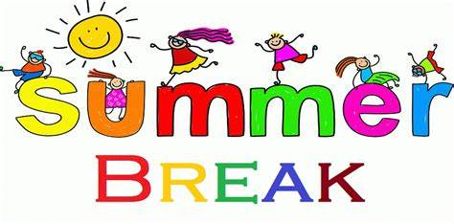

Principal’s Message
What at year! I am very proud of our students and staff for the resilience they have shown over the course of the year. They navigated several changes due to changing health orders and worked through significant stressors from extenuating circumstances. I am happy that we are ending our school year on a strong note! In the last two months we have got to see big smiles on our students’ faces as they once again had the opportunity to enjoy the fun stuff! Festival of the Arts, Primary Play Day, Track and Field days, and field trips showcased students skills and allowed for recognition of their hard work. It was amazing to be able to invite parents back at our school to share in the positive atmosphere we have greatly missed over the last two years!
The staff are greatly looking forward to welcoming the students back in September after we have all had some rest and relaxation over the summer. On that note, we would like to wish everyone a safe, healthy, and fun summer vacation!

Penny’s Art Show – Digital Art Gallery
The Indigenous Art that Penny Reid planned for and organized at the Parkside Gallery was a tremendous hit. So special to be able to value and celebrate the artistic talent and creativity of our students through Indigenous Art. Penny ensured that every student had an entry piece in this show. Ms. Davidson has honoured Penny and our students by capturing the exhibit in a virtual art show for everyone to enjoy.

Indigenous Art Show by 100 Mile Elementary

PAC & CPF
I would like to recognize the dedication and commitment of the parents who sit on the executive committee of our PAC and CPF. These ladies have stuck by our side throughout the last few years. They are an amazing group who show up to the school with smiles and looking for ways they can help.
On behalf of 100 Mile Elementary school community, I would like to extend a BIG THANK YOU!!

2022 Bus Registration – ALL Bus Students!
If your child rides the bus they MUST register for next year.
This applies to ALL bus students not just new bus students. Please use this link to register your children
September 2022 - Bus Registration

