GROW March 8th Event with Drum Making and Beading

Overview
On March 8th, students in grades K-7 enrolled in School District #27’s distributed learning program, GROW, came together at the Central Cariboo Arts Centre in Williams Lake for an Indigenous learning experience. This event was made possible through funding provided by FNEC.

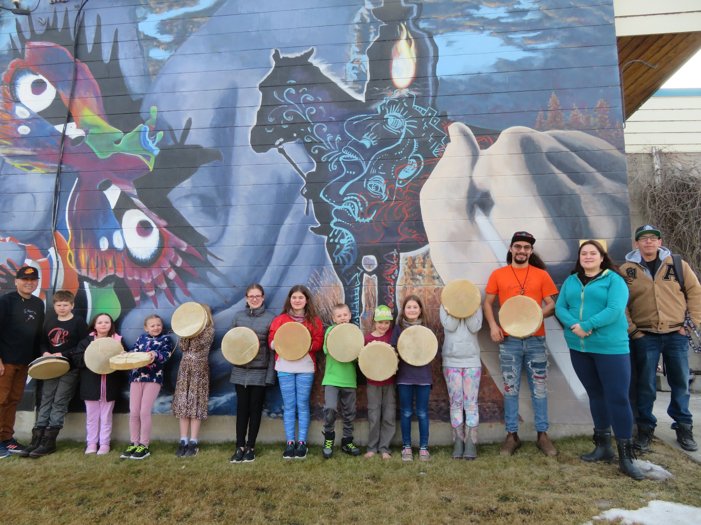

Students aged 8 and over participated in a drum-making workshop led by Bruce Baptiste, a cultural ambassador at Denisiqi Services Society, and a member of the Tŝilhqot’in Nation. With him were several other employees from Denisiqi, including Wynne Vaughan, Erik Schuetze, and Willie Cooper. Students aged 7 and younger learned how to do some beading with Ada Phillips from the Xatśūll First Nation.

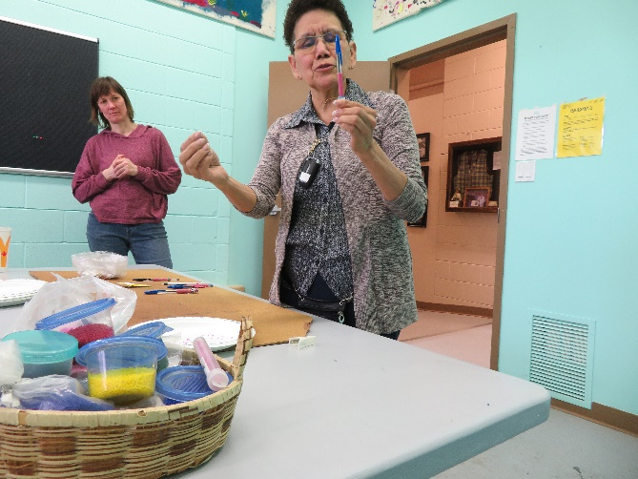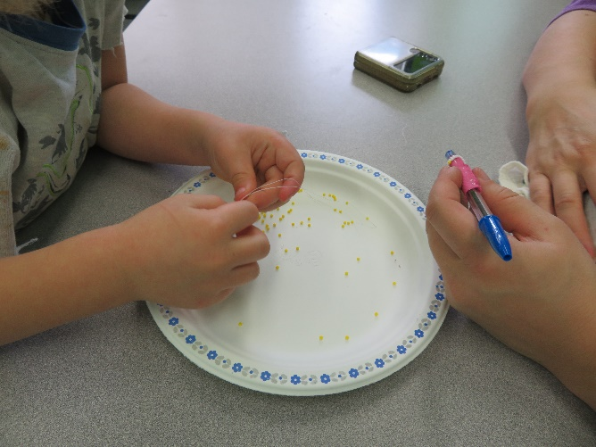

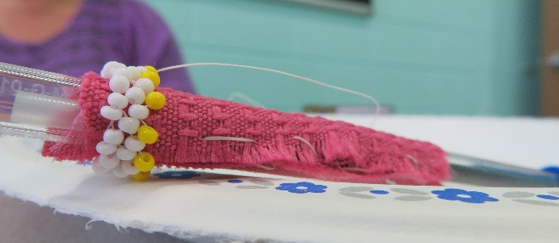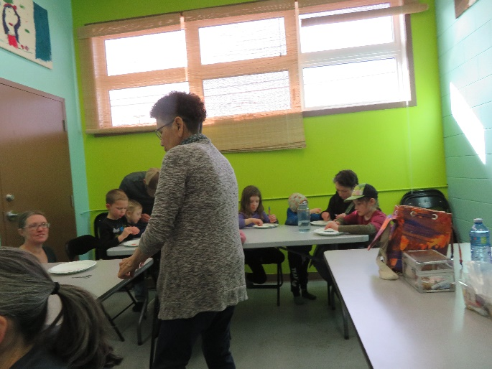

Learning During the Event

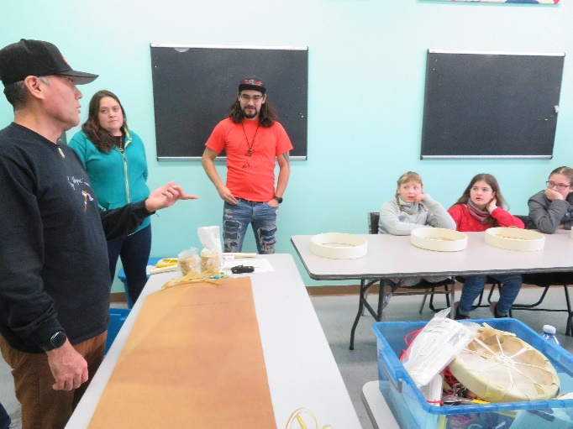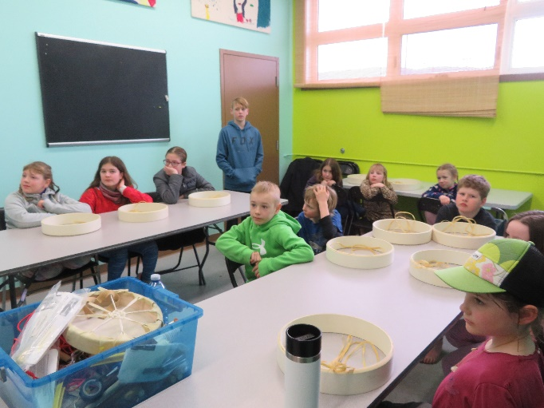

GROW families were introduced to the protocol around having an event and welcoming First Nations knowledge keepers, included giving a land acknowledgement and listening respectfully. Bruce, Wynne, Erik, and Willie introduced themselves and each spoke a little bit about their Nation. They demonstrated the drum-making process and then spent a lot of time moving about the room, helping individual students with their own drums. Students were able to make personal connections with them and to learn a little bit about their work at Denisiqi. Many of GROW’s students have been a little isolated from authentic First Nations learning experiences due to them learning at home and not being in a physical school where these experiences are curated. The personal conversations and connections they were able to make on this day closed some of the distance they were feeling between themselves and Indigenous learning.

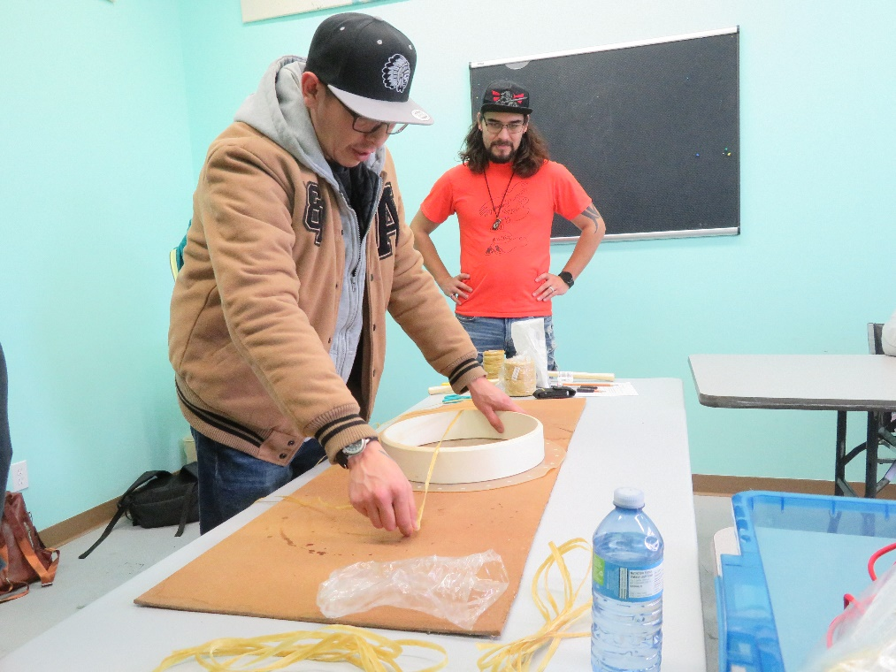

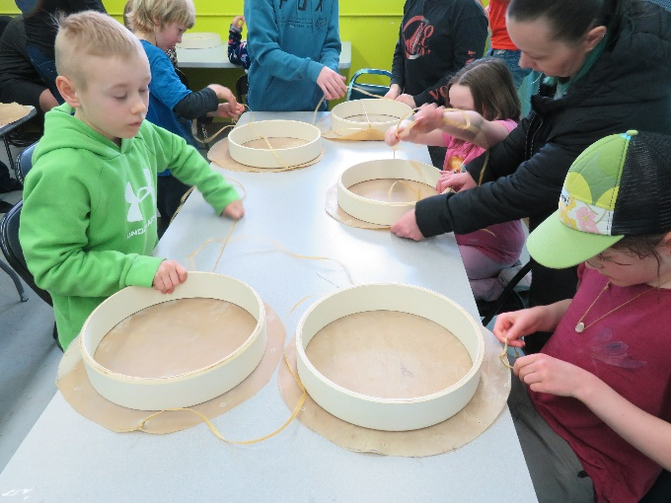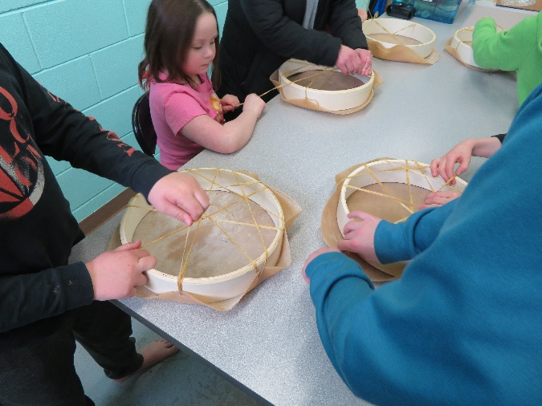

As students worked on their drums or beading activities, they learned about how the materials were originally made for these. They also got the satisfaction of creating something useful and beautiful with their hands, and learned different ways they could individualize their own projects. Students learned how to dry and properly care for their drums.
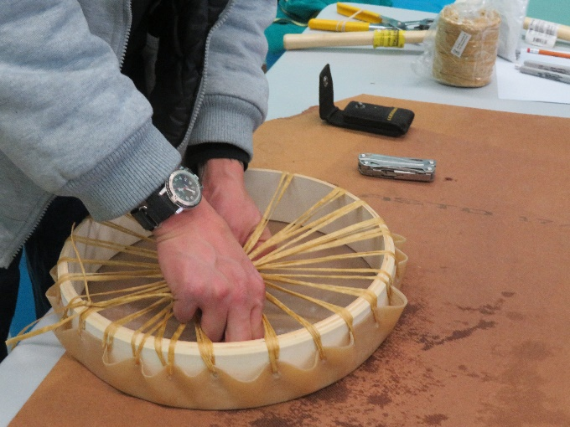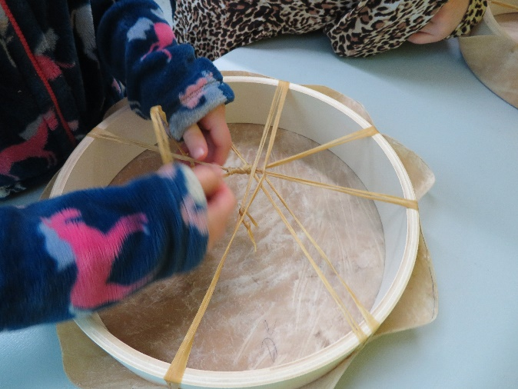

Students were also invited to participate in drumming at Denisiqi once their drums were dried and taught how to paint their drums if they wanted.

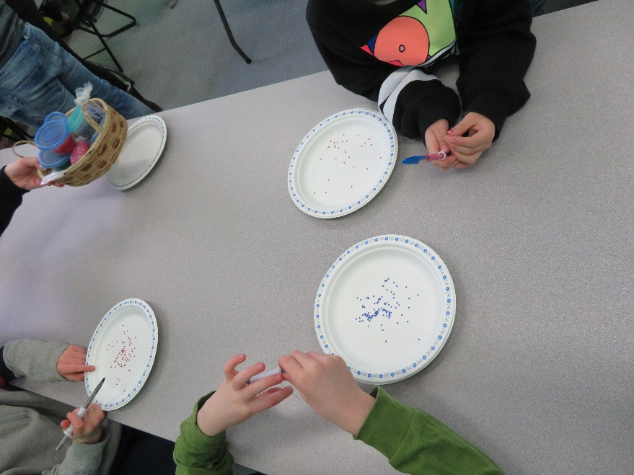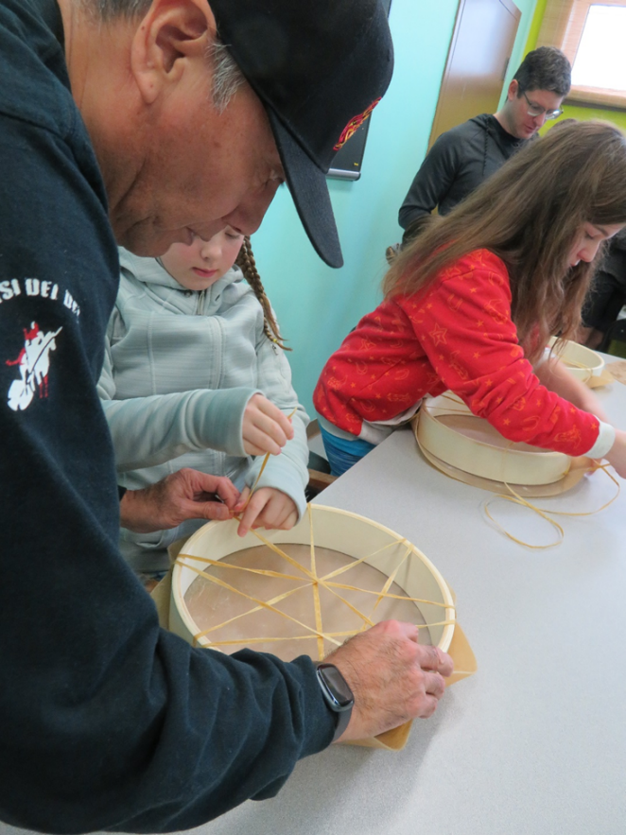

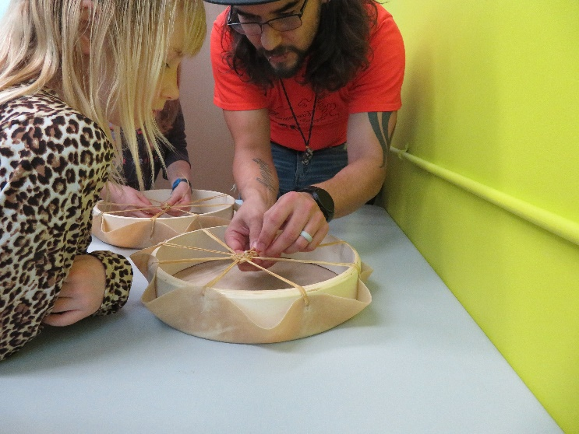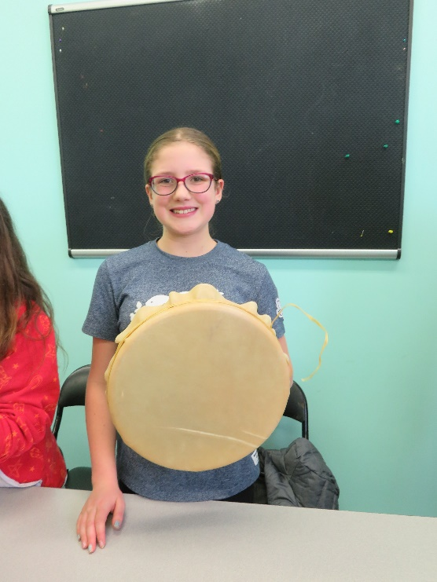

Measures of Success
Besides being able to watch the students and parents relax, participate, and make connections at the event, conversations with parents and students afterward also gave evidence to the success of this activity.

Families expressed that they were pleasantly surprised that the tone of the day was about connection and the sharing of knowledge rather than about trauma experienced in the past. They realized their limited exposure to learning about First Nations through Truth and Reconciliation Day activities was nowhere near the full picture, and that local First Nations have a wealth of cultural knowledge that is interesting, useful, and that they are more than willing to share.

Our First Nations students who participated in the event were able to shine on this day by participating in activities that connected them to their own culture and showcased that to their peers.

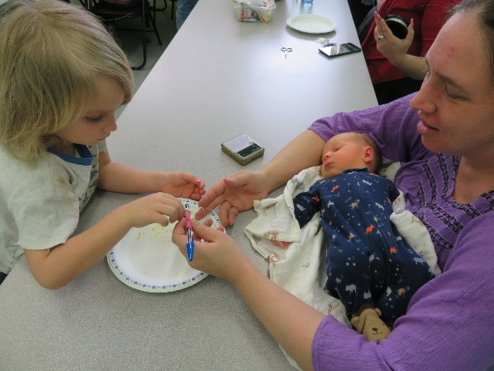
Next Steps
Going forward, GROW hopes to bring more of these place-based, authentic learning experiences to its students and their families. These types of experiences are essential in connecting families to their local First Nations and the teachings they can offer.

