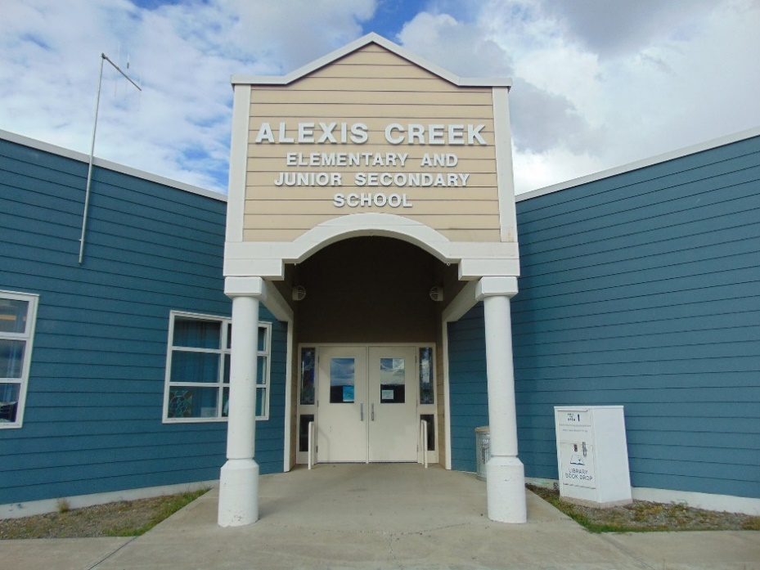
ACES May Newsletter
Upcoming Events  PAC Meeting  Monday, May 27th at 3:05 in the Library  Secondary report updates were mailed out and are available online.  Spirit Days:  May 23rd Bad Hair Day  May 29th, Trivia Day  May 16th, Indigenous Cultural Week: Field Trip to the Nemiah Valley  May 20th, 2024, is Victoria Day, no school.  June 14th, Field Trip: Hanceville Fish Hatchery TNG  June 27th, Last day of school. |  | Principal Thoughts  On May 27th, PAC will be meeting in the library afterschool. I am unable to attend this meeting. I want to thank our PAC parents for their support and help with planning and bringing in events to Alexis Creek School.  This month, we will be having two “Spirit Day” events. Spirit days are special days, where students can attend school by showing up dressed in the school’s theme for that day. On May 23rd, we be having a “Bad Hair Day” and on May 29th, we will have Canadian Trivia Day.  On May 2nd, and May 6th, we hosted Bike Days, and Mary Forbes came out to our school and ran her bike program. Mary made positive memories for everyone. The students were very engaged, as Mary taught them about using real tools. Covering such things as safety, names of tools, names of bike parts, how things work and how things go back together. Students of all ages were excited to pull bikes apart. The parts are then used to re-build a bike. Miah was gifted a rebuilt bike as a birthday present. Happy birthday Miah!  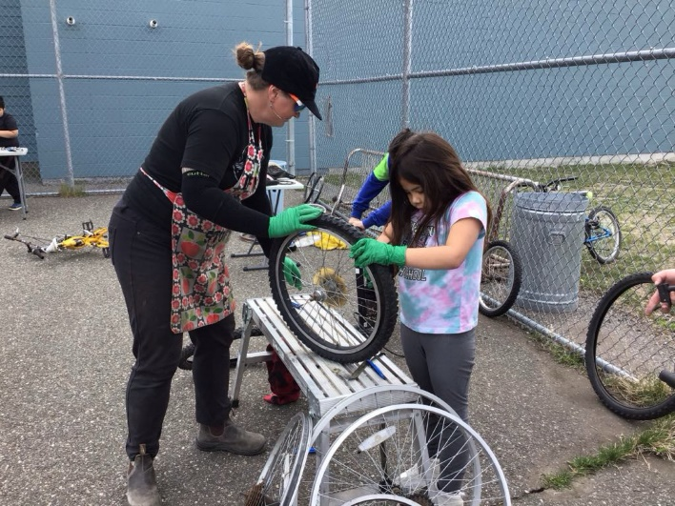  We have some field trips coming up, please make note of the dates on the left.  May 16th, we will be getting up early. The bus will be leaving the school early at 7:00 am to drive out to the Nemiah Valley for cultural awareness week. After the bus leaves the school at 7:00 am, it will drive through Anaham doing reverse run, then it will pick up students in Stone. We hope to be in Nemiah around 10 am. Students will be completing projects at various stations; we have been invited for lunch. We will be leaving at 1:00 pm and will arrive back at the school approximately 4:00 pm.  May 20th is a statutory holiday. No school.  June 14th, we are planning field trip in the morning to the Hanceville Fish Hatchery. More details to come.  Please don’t hesitate to call the school if you have a question or a concern, 250-394-4346.  Regards,  Ms. Helen Wight

