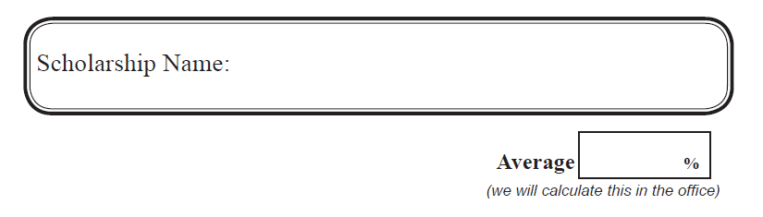

Your Full Name:
Sin # |  | Birthdate:
Mailing Address:
Home Phone #: |  | Cell Phone #:
Career Intentions: (If undecided, list a couple of choices)

Post-Secondary Institution(s) you plan to attend, in order of importance to you.
 | 1.
 | 2.
 | 3.
Program:
Length of Program:
Cost of tuition (yearly): |  |  |  |  |  | Cost of books:
Other Costs: (specify)

Current Employer: (where do you work)
Current School Clubs and/or Sports (e.g. PSO Rugby, Grad Council, Leadership, etc.)

Current Community Clubs and/or Sports & Volunteer Positions (e.g. Performing Arts Society, Hockey etc.)

Fathers Name: |  | Mothers Name:
Occupation: |  | Occupation:
Employer: |  | Employer:

By signing this form, I am authorizing my school to release my grades to the SD#27 - PSO Scholarship Committee for the purpose of determining scholarship distributions.
Student Signature: _______________________ Parent Signature: _________________________

