PETER SKENE OGDEN
SECONDARY SCHOOL – ÉCOLE SECONDAIRE
https://www.sd27.bc.ca/pso

Our mission is to provide supportive educational and social opportunities for students to be
successful and thoughtful citizens.

Grade 8 Course Selection Guide
2024-2025

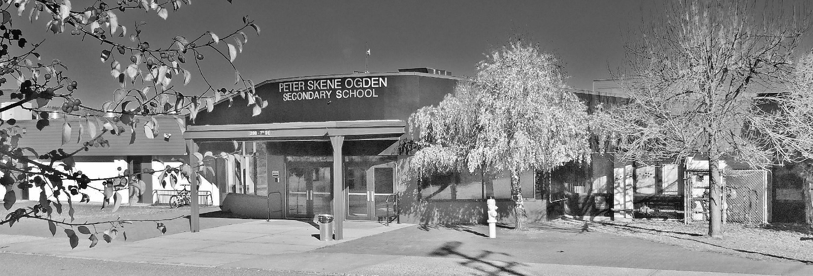

PSO: Providing Students Opportunities

Principal: Ms. Caitlin Currie

Vice Principal: Mr. Shawn Meville

Counsellors: Mr. Ian Watson

Indigenous Student
Support Workers: Angel Smith or Sharmaine Grimes

Welcome to Peter Skene Ogden Secondary

To Grade 7 students and their parents,
We are looking forward to welcoming you to Peter Skene Ogden! Grade 8 is an exciting and challenging time in your life. It is the beginning of your time at a new secondary school. It is exciting because you will meet many new friends and experience new and interesting elective courses. It will be challenging because you will have a variety of different teachers and courses, which will require you to be well organized. To be successful, it will also be necessary to establish a daily home study schedule. The teachers are also excited about your coming to Peter Skene Ogden. We hope you will have a great and successful year, as you embark upon a five-year secondary program.
All grade eight students must take English, Mathematics, Social Studies, Science, Physical Education, and a language. Grade eight students will have an equivalent of two full blocks of electives. The intention of these blocks is to give each grade eight student a sampling of some of the electives offered such as Art, Outdoor Ed, Woodwork, Metalwork, Foods, Band, and Computers.
Please fill out the course selection form and return it to your elementary school teacher as soon as you are able. They will send the form on to us so we can start getting things set up for next year. Later in the year we will have all the grade 7s visit PSO and give them more information about how PSO works. Parents and students are welcome to contact the counselling office at 250-395-2461 and speak with Ian Watson about any questions you may have.
For more specific information regarding courses, parents and students can go to www.sd27.bc.ca/PSO and look under the OFFICE tab for Course Selection Guides.
Sincerely,
Peter Skene Ogden Administration and Counselling Staff

TIMETABLE
Peter Skene Ogden's timetable is based on a linear/semester system. There are 4 terms and 2 semesters. Courses may be taken for 1 term, 1 semester, or for a full year:
Semester 1: Terms 1 and 2
Semester 2: Terms 3 and 4

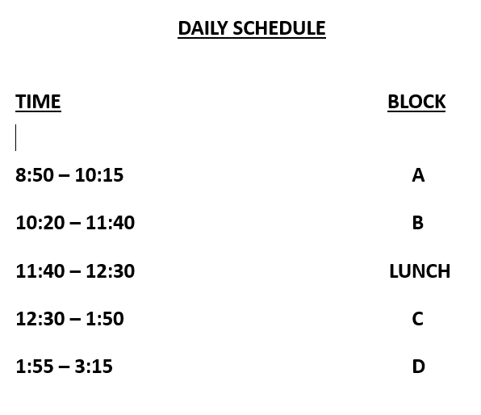

GRADING AND REPORTING PROCEDURES
Grading in a subject is based on Ministry of Education standards and validated contemporary practices. Evaluation is based on homework exercises, reports, project work, oral work, short quizzes, and formal examinations. Participation is critical to all of these areas and success requires good attendance. There will be a total of four (4) report cards in addition to interim reports issued throughout the school year as the need arises.

Grades for Gr 8 and Gr 9 are assigned on the same proficiency scale students are accustomed to from their K-7 report cards.
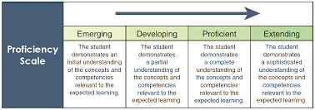

SCHOOL AND HOME COMMUNICATION

School contacts are made periodically by letters or telephone calls as is necessary to keep parents aware of any developing challenges. Parents are invited to phone the teacher for updates and progress reports. Please

Please ensure your email and phone contact info are up to date. You can reach out to the PSO office at any time to update your details. Student verification forms will be sent home in June to Gr 7 students—updates can be made at this time.

PSO COUNSELLING DEPARTMENT

Counsellor: Mr. Ian Watson – All Students
Indigenous Support Workers: Angel Smith and Sharmaine Grimes
Youth Engagement Worker: Nicki Hansen

ROLES AND RESPONSIBILITIES OF SCHOOL COUNSELLORS

- Problem-solving and planning for students
- Academic programming for all students
- Personal counselling for social and emotional issues
- Post-secondary and scholarship planning
- Academic advising
- Career Exploration

MAKING COUNSELLING APPOINTMENTS

Counsellors are available for counselling appointments from 8:30 until 3:30 on most school days.

REFERRALS TO OUTSIDE AGENCIES

Occasionally, students will require support for personal issues that go beyond the scope of a school counselling role. PSO school counsellors will be happy to assist students and their families in making referrals to outside agencies. Please do not hesitate to ask for information about counselling support outside of school.

COURSE CHANGES

In addition to regular counselling duties, counsellors also assist students with course selection and course changes. Course selections are done in the early spring (usually in a group format) although individual one-on-one sessions are also available. Once timetables are complete and the new semester begins, students may change courses only within the time outlined in the school calendar.

GRADE 8 CORE AND ELECTIVE COURSES

GRADE 8 REQUIRED COURSES

1. Mathematics
2. English
3. Physical Education
4. Science
5. Social Studies
6. Language 8 (French, Spanish, or Shuswap)
7. Explorations Package
(Equivalent of 2 full blocks. Woodwork, Metalwork, Art, Computers, Foods and Outdoor Ed)

LANGUAGES

At the Grade 8 level the study of a second language is mandatory. At the grade 9 level second language study is no longer compulsory. Please note: Many universities require French or another second language for entrance requirements. Second language proficiency also makes Government, military, police and some industrial jobs more accessible. Students who plan to go to university are advised to maintain a second language course in their secondary school years.

FRENCH

This course is designed to teach basic communication skills through reading, speaking, listening and writing. Students will also read easy reader style books in French. Special vocabularies and expressions for holidays or cultural events will be introduced throughout the year.

FRENCH IMMERSION PROGRAM
Only open to students who were enrolled in a French Immersion Program in Grade 7. In grade 8, French Immersion students are required to take 3 French Immersion courses. They are: French Immersion Language 8, French Immersion Phys. Ed. 8, French Immersion Socials 8. Additionally French Immersion students are required to take Math 8, English 8 and Science 8 as well as the Explorations package.

FIRST NATIONS LANGUAGE (SHUSWAP)

This course will offer an-depth study of the Shuswap language, history, culture and issues of the First Nation people. The language is spoken as far south as the Okanagan and as far north as Quesnel. This introductory course will give students a broad view of the oral dialogue of the Shuswap people and then move into studying sentence structure – written and oral.

ELECTIVE PACKAGE
COMPUTER STUDIES

This completely revamped computer studies course is an intense hands-on programming presented in a visual and stimulating manner (angry birds and evil pigs are involved). Students will learn to create and present their work through the use of animation, simple programs, and group projects. Programs, such as Word, Excel, and PowerPoint, will be covered. No computer experience is needed to take this course.
ART
In this course students will explore the fundamentals of art through drawing, painting, printmaking, and sculpting. Developing ways to create and express interesting personal images in the form of drawing and painting will be the emphasis of this course. Creating ideas with a variety of media will help students develop a unique form of artistic expression. Depending on ability and interest of the students, projects may also include 3D art creations or lino-printing projects.

BAND

Students will be involved in listening to, creating, and performing music as well as studying music theory and history. Students are expected to practice regularly. Attendance is mandatory for all rehearsals, concerts and festivals. If you do not already own an instrument, there are school-owned instruments available for a very low rental fee. Band 8 is an elective, so students that select this option will take it in place of some of the general elective rotation package.
FOOD STUDIES
Foods is an introduction to basic, healthy cooking and baking skills. Students will be able to cook/bake a variety of items such as breakfasts, pasta, soup, muffins, and cookies.

METALWORK

This fast-paced, “make-and-take” course is for anyone who wants to get up out of their chair and get busy! Pouring, pounding, welding, and sculpting. You will discover fresh new tools and learn stimulating skills that will be in high demand when you graduate. Plus, you will take home stunning, long-lasting projects that your parents will hardly believe you made! Join us and discover why so many students find this fun course to be their favorite at PSO.

WOODWORK

This is a hands-on course that introduces students to the basic principles of carpentry. The safe and correct use of both hand and power tools is a major component of the course. Students will learn the basic skills involved in wood joints and joinery, gluing, clamping and project finishing. Projects will vary by course, student ability/motivation and interests.

OUTDOOR ED

This course focuses on preparing students for participation in a variety of outdoor activities and experiences. There are three focuses for this course. It will provide you with a greater understanding and appreciation of what is required when planning and going on an outdoor trip, including learning about emergency equipment and planning. You will also develop a greater understanding and ability of working as a group and looking out for more than just yourself.

SUGGESTED LIST OF SUPPLIES LI
ES
Students will be expected to supply the following:
- Loose leaf paper
- Binders: large (with dividers) or small
- Pens, pencils, eraser, a metric ruler, a geometry set
- pencil crayons or felt pens (optional)
- Gym strip: shorts or sweats, t-shirt, socks, runners, and a lock for the P.E. locker
- Calculator – preferably 2 line

HOMEWORK AND ORGANIZATION

We recommend that students spend 30-45 minutes of their time in the evening on schoolwork; including homework, review, project work and studying for tests.

HOMEWORK REQUESTS

For long-term illnesses, requests should be directed to the office.

LOCKER AND LOCKS

Each student will receive his/her own individual locker. Lockers remain the property of the school and are loaned to students for their use. Students are expected to keep their lockers clean and secured with a combination lock, which come with each locker assigned to each student.

FINANCIAL HARDSHIP POLICY FOR CURRICULAR ACTIVITIES

No student will be denied the opportunity to participate in a course and /or activity associated with a course in which they are enrolled because of financial hardship.

Parents/Guardians and/or students should contact the school principal or counselling staff in order that confidential, respectful and discreet arrangements can be made to ensure that student is not denied an opportunity to participate in a course or activity associated with course.

