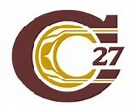
Cariboo-Chilcotin School District

2021-2022 School Plan for Learner Success

School Name: Naghtaneqed Elementary - Secondary
Ministry of Education Framework: A shared commitment to improve student success, equity and inclusivity of learning outcomes for all students with a particular focus on Indigenous students, children and youth in care and students with disabilities or diverse abilities.
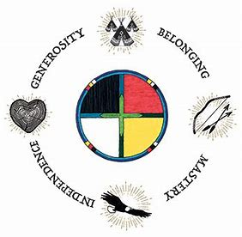
Circle of Courage: (Brendtro, Brokenleg, Van Bockern, 1990) emphasizes the four growth needs of all children: Belonging, Mastery, Independence, and Generosity. This model informs teaching and educational decision-making in the District and is expected to be considered in school planning for learner success.
Intellectual Development
Educational Outcome 1: Students will meet or exceed literacy expectations for each grade level
2020-2021 Results:
- Percentage of students meeting or exceeding literacy expectations:
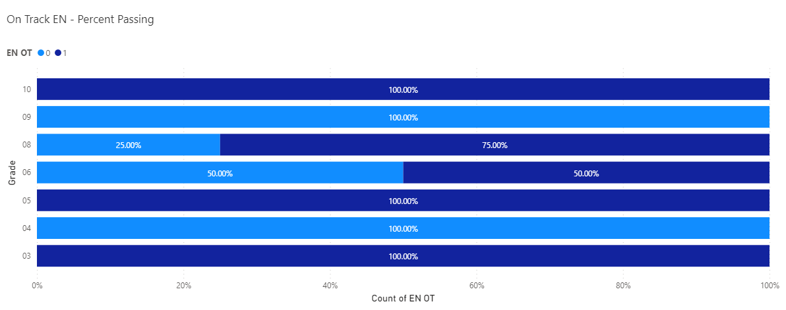

2021-2022 Goals and Focus Areas:
- Students in grades 4-9 will advance one year reading level as determined by the Dart assessment.
Strategies and Structures:
- Actions for Enhancing Student Learning and Experience
  - Students will be assessed using the Dart Literacy Assessment given in fall and spring.
  - Students will be assessed by two school-wide-writes
  - All students in grade 5-7 requiring support will be given explicit one on one instruction for 20 minutes each day focusing on targeted remediation of phonemic awareness, fluency, and reading strategies
  - All students in grade 5-7 will participate in a home reading program targeting 20 minutes of reading a minimum of 4 days a week

- Actions for Enhancing Staff Capacity & Learning
  - Staff will collaborate daily as we develop strategies to improve language acquisition skills within our Chilcotin language emersion program.

Educational Outcome 2: Students will meet or exceed numeracy expectations for each grade level
2020-2021 Results:
- Percentage of students meeting or exceeding numeracy expectations:
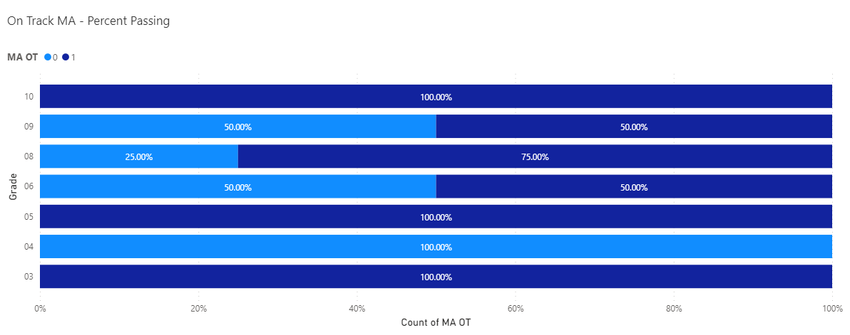

2021-2022 Goals and Focus Areas:
- Improve the number and percentage of students grades 4-9 meeting or exceeding expectations in numeracy

Strategies and Structures:
- Actions for Enhancing Student Learning and Experience
  - Apply the Vancouver Island Numeracy Assessment at the start of each new math unit
  - Small group in-class support for identified gaps in number sense or extension of learning
- Actions for Enhancing Staff Capacity & Learning
  - School will focus on teaching/assessing Numeracy ex. Peter Liljedahl - Professional development on the Thinking Classroom
  - Apply First Peoples Principles of learning in practice for math
Human and Social Development
Educational Outcome 3: Students will feel welcome, safe, and connected to their school
3. 1 Attendance
2020-2021 Results:
- Percentage of students attending 80% or greater end of June 2020:
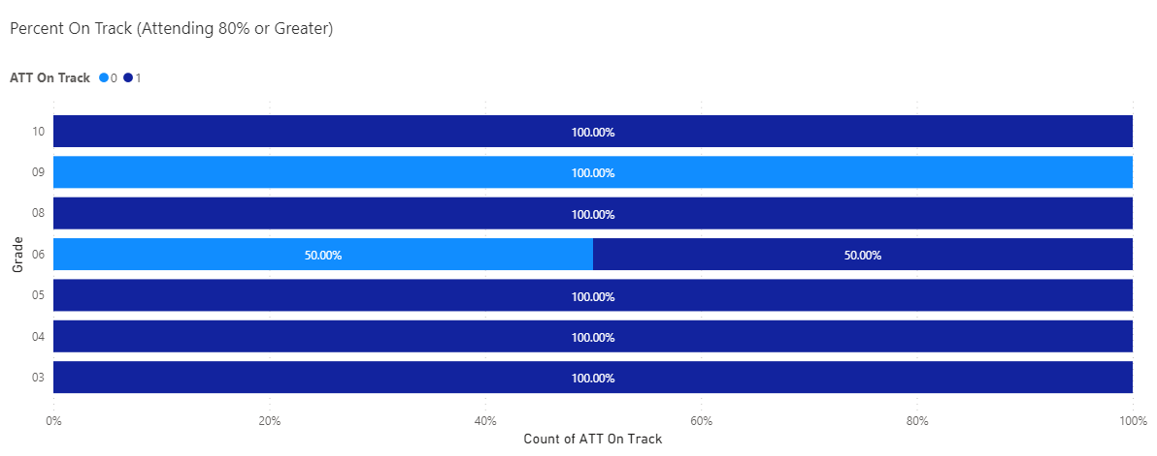

2021-2022 Goals and Focus Areas:
- 100% of students attending 80% or greater end of June 2022

3.2 Connection to School
2020-2021 Results
- Percentage of students in grades 4, 7, 10 who report feeling welcome in their school during 2020-2021
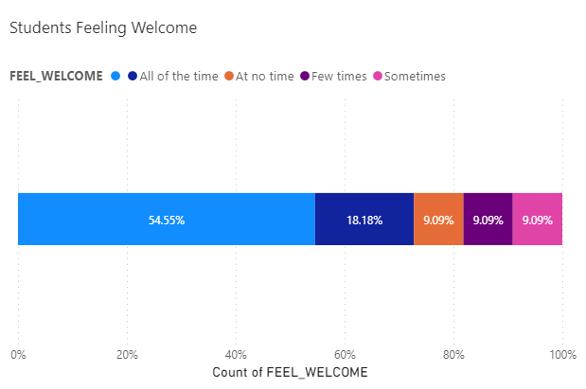

- Percentage of students in grades 4, 7, 10 who report having a sense of belonging in their school during 2020-2021:
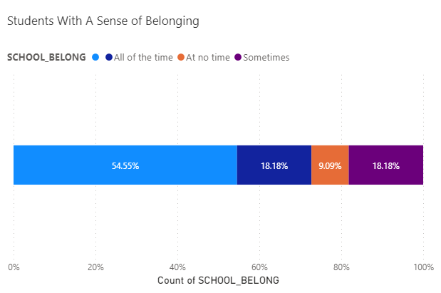

Goals and Focus Areas
- Students will experience a sense of belonging in our learning community as they become competent in Chilcotin through daily instruction.
- Students will value performing at their potential resulting in improved learning when they develop a sense of pride and foster a sense of well-being culturally.
Strategies and Structures
- Actions for Enhancing Student Learning and Experience
- Students in grade 5-7 will do language arts, science, and social studies in both Chilcotin and English throughout each day.
- Students will each create an individual short video in Chilcotin which expresses what it means to be a part of the Xeni Gwet'in and live in Nemiah Valley.
- All students will receive instruction in Chilcotin language and culture.
- All students will participate in our school and community “Chilcotin Culture Week”
- Our “Code of Conduct” RAMS for Success will enhance student self-esteem and build our learning community.
- Provide a healthy hot lunch and snack program supported by the Xeni Gwet’in Band and Community Links.
- When deciding upon content that will be incorporated into the school or classroom, begin by checking with the local First Nation’s community or Aboriginal organizations.
- Create a healthy and safe school environment.
- Bridge the gap between classrooms, community, and generations.
- Implementing Indian Residential School Survivor Program
- Enrich the school learning environment with Chilcotin drumming and singing.
- Incorporating First Nations culture and traditions into all curricular areas
- Take learning outside on the land whenever possible.
- Students will participate in our Ridge Walker hiking club. Our moto, “Do a Little More Than You Did Before!”, will inspire students to reach new heights in the mountains as well as our learning opportunities.
- Integrate traditional foods into our activities, where possible, including Indian Ice-cream, Indian Tea, wild potatoes, bannock, dried meat and fish.
- Students will harvest traditional foods like wild potatoes and onions.
- Students will explore horse management. Horse culture runs deep throughout Xeni Gwet’in culture historically as well as present day.
- Students create traditional toys and beaded crafts.
- Students will join elders at the traditional village of the Xeni Gwet’in to collect pine tree pitch and learn how to prepare traditional pitch medicine.
- Students will learn about the importance of maintaining a knowledge connection with their history and responsibility to keep those traditions vital in our modern society.

- Actions for Enhancing Staff Capacity & Learning
- Always consider how The First Peoples Principles of Learning can be integrated with learning opportunities.
- Develop understanding and application of The Seven Grandfather Teachings.
- Develop knowledge and application of the oral tradition.
- Active involvement in community, inclusion of all resources
- Develop more awareness of self-care both in students and staff by focusing on Trauma-Informed practices and Self-Regulation (Dr. Stuart Shanker).
- Naghtaneqed School will continue to develop our Chilcotin Emersion Program during the 2021-2022 school year.
- Students will be surveyed in June to determine the level of their sense of belonging and how welcome they feel at school.
- Invest time in recognizing our inter-connectedness between everyday life and the natural world and the importance of maintaining health and balance: rod fishing, ice fishing, animal tracking, cross-country skiing, snowshoeing, plant identification and preservation, landmark explorations, resource stewardship, medicine walks
- Office referrals will be reviewed in June with the goal that their frequency will decrease throughout the year and students will overcome challenges with greater confidence and resiliency.
- Regular rural school principal meetings focused on maximizing student learning and transitioning students into attending urban high schools.

3.3 Careers and Core Competencies
- Grade 9 students will be responsible to navigate the Cariboo-Chilcotin Virtual Secondary School courses. They will be required to operate a laptop, necessary software, and Teams independently.
- Intermediate students will explore 5 mini-career kits provided by the SD#27’s Career Development Department.
- Intermediates will explore robots and coding while engaging with Alana Meyers, SD#27’s Intermediate Career Development Coordinator.
- Intermediates will develop increased capacity needed to operate a laptop and necessary software.
- Grade 9 students will investigate career opportunities within their community and beyond.
Other Focus Area
Building community:
- All students will be required to participate in and contribute to our daily community building exercises including teamwork, leadership, peer support, challenges, cultural activities, identifying individual strengths, and community engagement.
- All students will explore an in-depth study into salmon including lifecycle, anatomy, habitat conservation, cultural significance, cultural practices, and resource management.

School Team Meeting Schedule:
Sep-Oct: Introduce updated school planning model. Review results from 2020-21 school year and fall assessments as staff (school-wide write, DART, Math assessment, etc.). Identify student focus groups and strategies and document in school plan.

Nov.: Complete FSA testing

Feb.: Review semester 1 report card data as a staff; Revisit focus areas of school plan. Celebrate success and modify focus areas as required.

Feb-Mar: Review FSA data alongside report card marks and assessments (triangulation). Celebrate success and adjust strategies as required.

Apr: Conduct Ministry Student Learning Survey

May-Jun: Complete all district assessments (school-wide write, Math assessment, EPRA/DART, etc.). Review results and compare alignment with report card data collected for term 2. Review student learning survey results and plan response.

June: Conduct Naghtaneqed student survey and analyze results

Jun: Review all available data for school for 2020-2021 school year.

Ongoing:
- School Plan for Learner Success as standing item on staff meeting agenda
- Monthly SBT review of attendance.

Glossary:
EA – Education Assistant

ELA – English Language Arts

EPRA/DART – Performance-based reading assessments, designed in British Columbia, by cohorts of BC educators, in response to teachers’ questions about how best to use assessment information to guide their reading instruction

FESL – Framework for Enhancing Student Learning: Ministry framework for ensuring shared commitment to improve student success, equity and inclusivity of learning outcomes for all students

FNCSW – First Nations Classroom Support Worker

FSA – Foundation Skills Assessment: Provincial assessment at the grade 4 and 7 level for Reading, Writing, and numeracy

Self-Regulation (Dr. Stuart Shanker) – the ability to monitor and modify emotions, to focus or shift attention, to control impulses, to tolerate frustration or delay gratification.

Student Learning Survey – A provincial survey conducted online once a year by the BC Ministry of Education to inform educational stakeholders about students’ school experience

SBT – School Based Team: A team led by the principal that assists classroom teachers to develop and implement instructional and/or management strategies and to coordinate support resources for students

School Wide Write – A SD 27 school-wide writing assessment completed by grades 1-10 every fall and spring. At Naghtaneqed, we have all students complete it twice a year (Gr. 1-10)

Naghtaneqed School Student Survey – A school developed survey that all students do once a year to inform staff at the school level how students view our school

SPLS – School Plan for Learner Success

Chilcotin Emersion Primary Program - Students will experience Chilcotin language and culture through emersion practices with additional English support for literacy and numeracy.

The Seven Grandfather Teachings - set of teachings on human conduct towards others. Originating from traditional Anishinaabe teachings from elders.

Trauma Informed Practice - a strengths-based framework grounded in an understanding of and responsiveness to the impact of trauma. It emphasizes physical, psychological, and emotional safety for everyone, and creates opportunities for survivors to rebuild a sense of control and empowerment.

Thinking Classrooms (Peter Liljedahl) – Dr. Peter Liljedahl is a Professor of Mathematics Education in the Faculty of Education and an associate member in the Department of Mathematics at Simon Fraser University in Vancouver, Canada. A “Thinking classroom” is a classroom that is not only conducive to thinking but also occasions thinking, a space that is inhabited by thinking individuals as well as individuals thinking collectively, learning together, and constructing knowledge and understanding through activity and discussion. It is a space wherein the teacher not only fosters thinking but also expects it, both implicitly and explicitly.

Faye Brownlie – One of BC’s most sought after literacy and learning experts. She works in staff development in BC, nationally and internationally.

Xeni Gwet’in – name of our local First Nation.

