

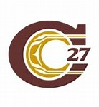**Cariboo-Chilcotin School District**

**2021-2022 School Plan for Learner Success**

**School Name: Lac la Hache Elementary**

**Ministry of Education Framework:** A shared commitment to **improve** student success, equity and inclusivity of learning **outcomes for all students** with a particular focus on Indigenous students, children and youth in care and students with disabilities or diverse abilities.

**Circle of Courage**: (Brendtro, Brokenleg, Van Bockern, 1990) emphasizes the four growth needs of all children: Belonging, Mastery, Independence, and Generosity. This model informs teaching and educational decision-making in the District and is expected to be considered in school planning for learner success.

**Intellectual Development**

**Educational Outcome 1:** **Students will meet or exceed literacy expectations for each grade level**

2020-2021 Results:

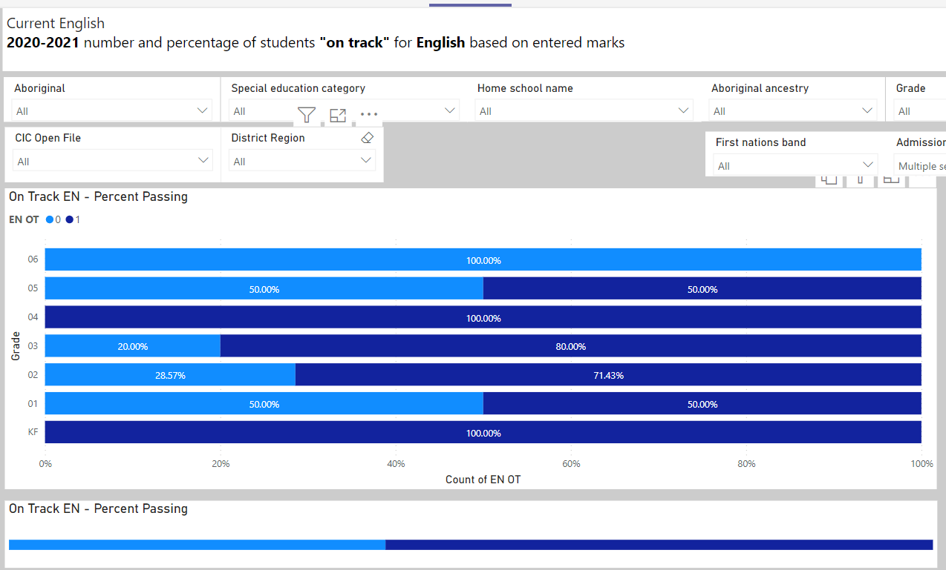

2021 – 2022 Results

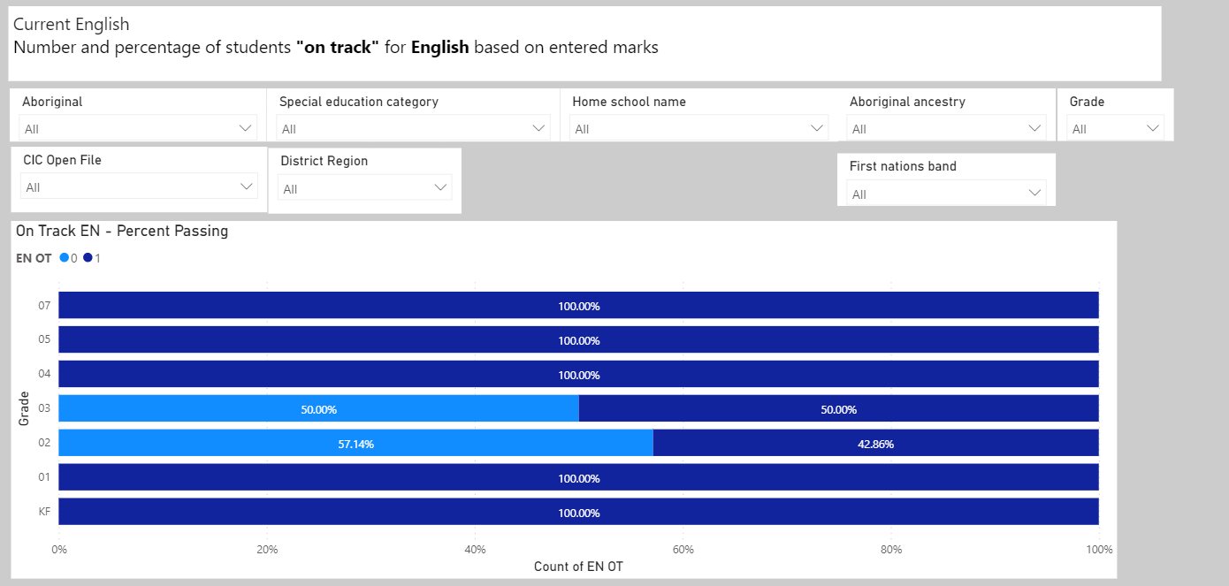

2021-2022 Goals and Focus Areas:

* Improve the number of students in grades K-7 meeting or exceeding expectations in literacy

Strategies and Structures:

* Actions for Enhancing Student Learning and Experience
  + School wide focus on explicitly teaching reading and writing strategies (using results from EPRA/DART/PM Benchmarks/SWW to identify needs)
  + Create a greater phonological awareness to enhance reading using Equipped for Reading Success by David Kilpatrick
  + Improve students writing skills using The Writing Strategies Book: Your Everything Guide to Developing Skilled Writers by Jennifer Serravallo
* Actions for Enhancing Staff Capacity & Learning

  School Based Team meetings focused on improving literacy results

* + - Whole staff review of EPRA/DART/PM Benchmark/SWW results and report card literacy marks – identify lagging skills and individual students for intervention if needed
    - Dedicated time to review/plan for using strategies from The Writing Strategies Book: Your Everything Guide to Developing Skilled Writers by Jennifer Serravallo

Support to implement guided reading in Primary Class

Reflections June 2022: Students have made some improvement in the scores on the assessments that we used this year. Support time with the Helping Teacher along with individual professional development in our classrooms have helped to support the growth we have seen in our students. Although we have seen some growth there is still work to be done.

**Educational Outcome 2:** Students will meet or exceed numeracy expectations for each grade level

2020-2021 Results:

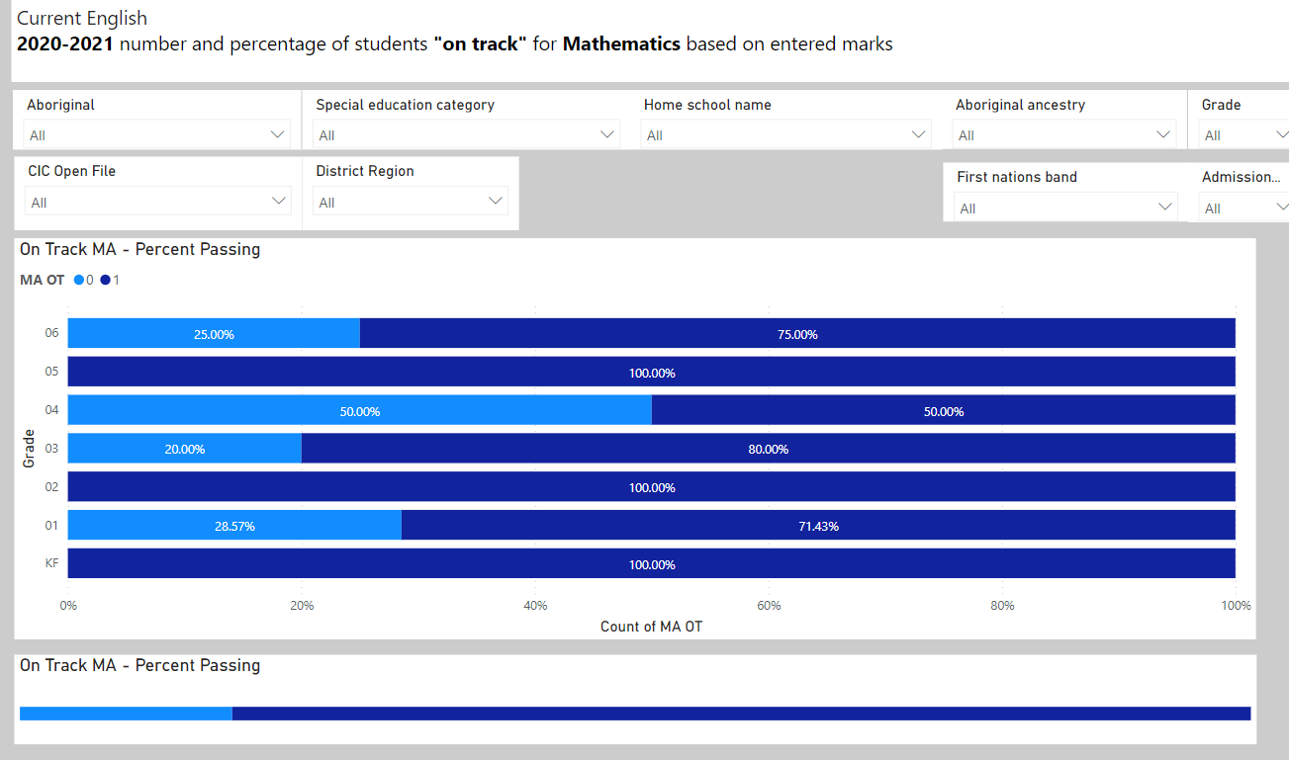

2021 – 2022 Results

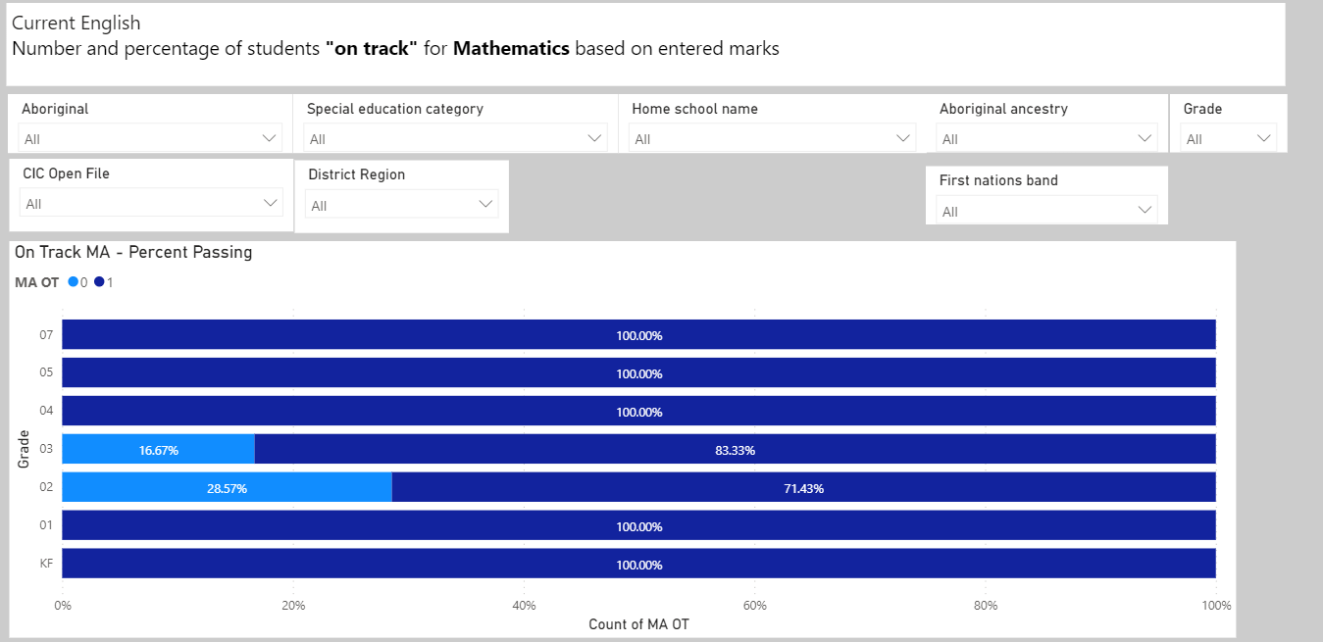

2021-2022 Goals and Focus Areas:

* Improve the number of students in grades K-7 meeting or exceeding expectations in numeracy

Strategies and Structures:

* Actions for Enhancing Student Learning and Experience
  + School wide focus on guided math instruction
  + Integration of technology (Math Prodigy, ABC Mouse, Osmos) into math stations
* Actions for Enhancing Staff Capacity & Learning
  + Review of FSA data to determine lagging skills
  + Use of The Vernon Screener (primary) and the Island Numeracy Assessment (INA) (intermediate) to help plan for instruction
  + School Math lead to attend Peter Liljedahl Math Pro-D and share learning with staff

Reflections June 2022: Students have made good improvement in the scores on the assessments that we used this year. District support professional Development, with Peter Liljedahl, and individual professional development in our classrooms have helped to support the growth we have seen in our students. Although we have seen good growth there is still work to be done.

**Human and Social Development**

**Educational Outcome 3:** **Students will feel welcome, safe and connected to their school**

*3. 1 Attendance*

2020-2021 Results:

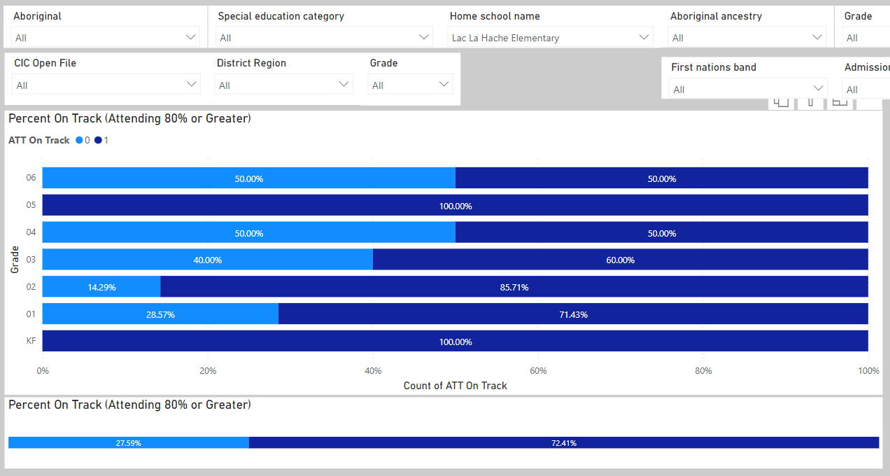

2021 – 2022 Results

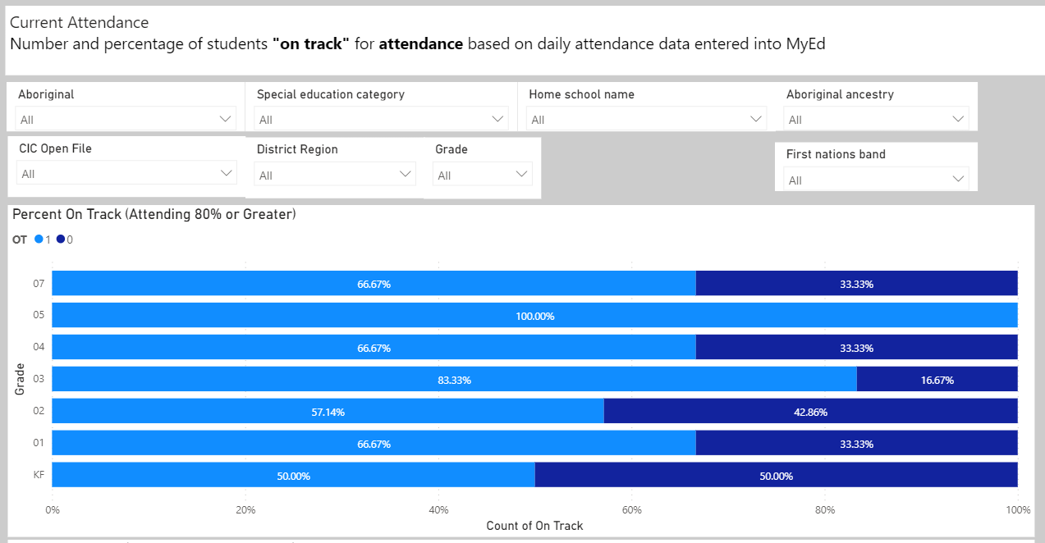

Goals and Focus Areas:

* 100% of students attending 80% or greater by the end of June 2022 (not including the students who are choosing (or required) to self-isolate during the on-going Covid-19 pandemic)

Reflections June 2022:

Covid was a large factor in the attendance over the last year and it shows that many of the students’ families were sensitive to the school setting and the impact it might have on their students. We were safe and cautious and followed the provided guide lines the best we could.

*3.2 Connection*

* Percentage of students in grade 4, who report feeling welcome in their school during 2019-2020

2020-2021 Results

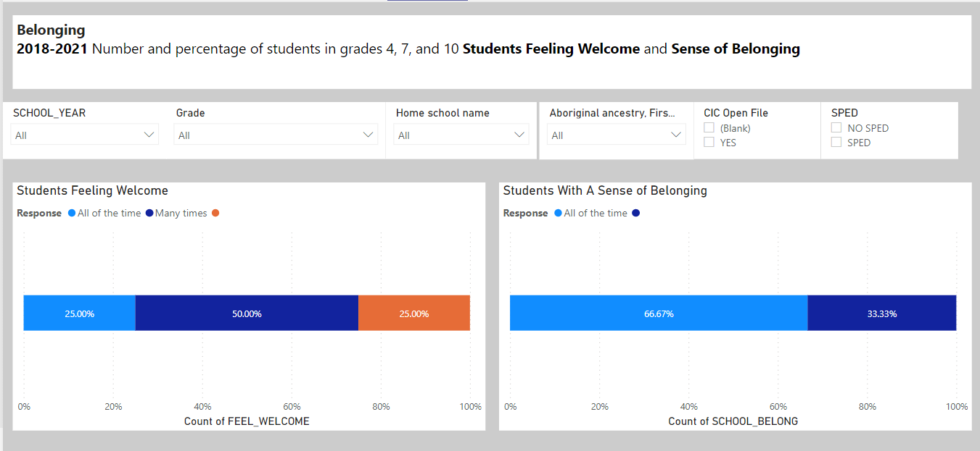

Results June 2022

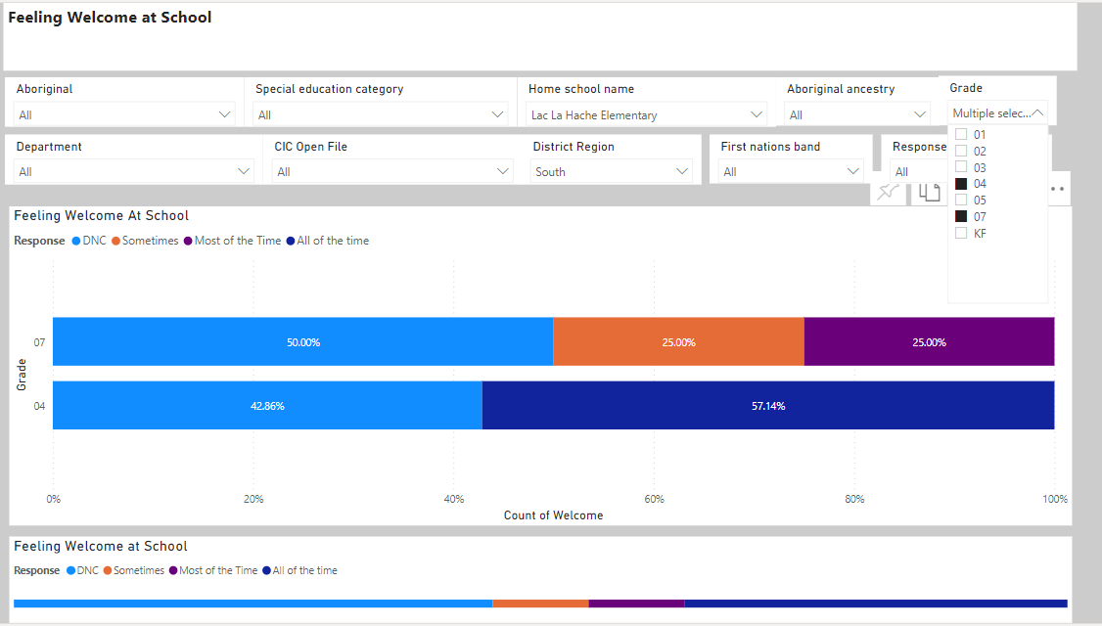

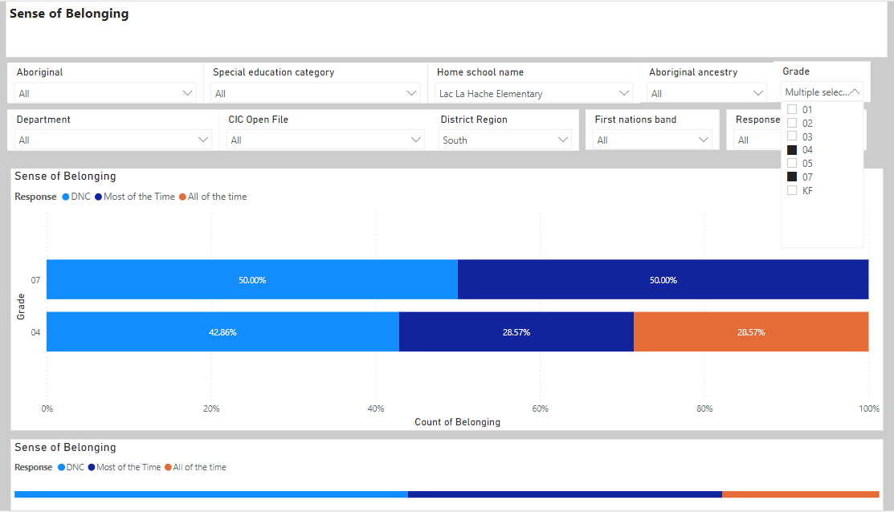

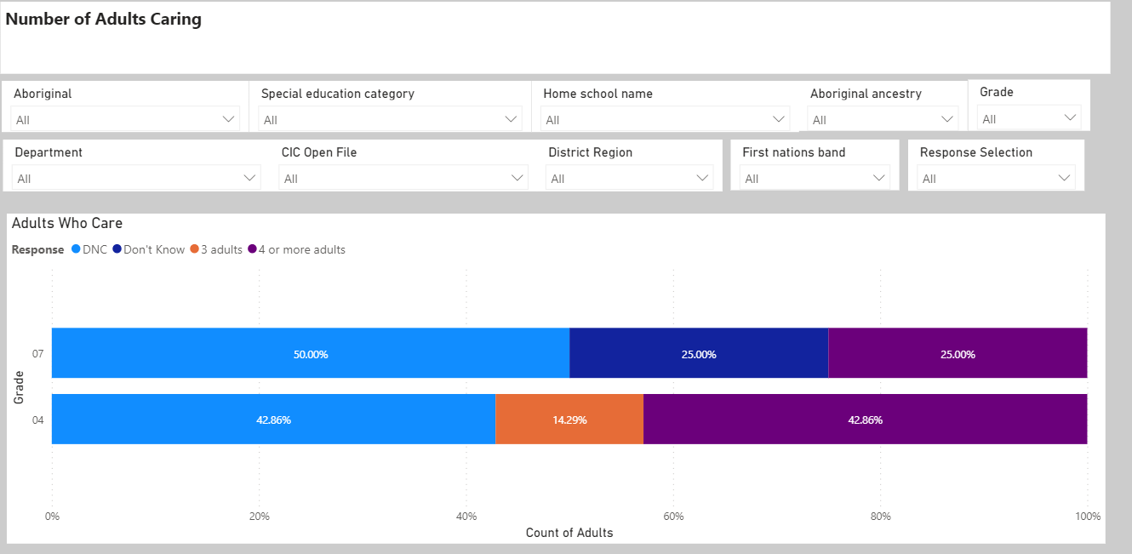

Goals and Focus Areas

* + Maintain the percentage of students who report feeling welcome and have a sense of belonging.
  + Include all grade 3-7 students in the sense of belonging survey to form a larger data base for next year

Strategies and Structures

* Actions for Enhancing Student Learning and Experience
  + Explore SOAR as a school acronym to teach/celebrate positive behaviour
  + Meals program: breakfast and lunch provided free of charge
  + Implement Stuart Shanker’s model for self-regulation
  + Participation in Wild Schools program and increase outdoor education
* Actions for Enhancing Staff Capacity & Learning
  + LEA PowerPoint presentation along with discussions and planning that focus on Indigenous Culture
  + Share learning with staff on Stuart Shanker self-regulation Pro-D
  + Participation in Wild Schools Pro-D (facilitated by our Wild Schools Coordinators)

Reflections June 2022 As a staff we have made great headway in looking at individuals and tailoring the approach to the students. We have looked closely at self-regulations and which needs are not being in students. We provide a meals program that encompasses the whole day and all students. We have grown into an accepting place with students needs being the main focus for our day.

**School Team Meeting Schedule:**

**Sep-Nov:**Introduce updated school planning model.  Plan for administering EPRA/Dart/Vernon Screener/INA/SWW and collect reading PM Benchmark data

Plan for Wild Days focus and Pro-D for the year

**Dec:** Review results from 2020-2021 school year and fall assessments as a staff.

**Jan:**Review term 1 report card data as a staff. Revisit focus areas of FESL plan.  Celebrate success and modify focus areas as required.

**Jan-Feb:**Compare FSA data to our SWW and report card marks.  Celebrate successes and adjust strategies as required.  Do a second SWW.

**Mar-Apr:** Review term 2 report data as a staff.  Revisit focus areas of FESL plan.  Celebrate success and modify focus areas as required.

**May-Jun:**Conduct third SWW as well as PM Benchmarks.  Review results and compare alignment with report card data collected for term 2.  Review student learning survey results.

**Jun:**Review all available data for school for 2021-2022 school year.

**Ongoing:**

* Meetings to review/plan for implementation of reading/writing strategies
* Monthly review of at-risk students (based on attendance/literacy/math results)

**Glossary:**

EPRA/DART – performance-based reading assessments to guide instruction for K-2 (EPRA) and grade 3-9 (DART) students

FESL – Framework for Enhancing Student Learning: Ministry framework for ensuring shared commitment to improve student success, equity and inclusivity of learning outcomes for all students.

FSA – Foundation Skills Assessment: Provincial assessment at the grade 4 and 7 level for Reading, Writing, and Numeracy.

Guided Reading/Math – small group instruction where a teacher supports each student’s developments at increasingly challenging levels of difficulty

INA – Island Numeracy Assessment – an intermediate math assessment to align numeracy assessment practices with current numeracy learning expectations of BC students

Peter Liljedahl – A professor of mathematics who regularly consults teachers, school districts and ministries of education on issues of teaching and learning, thinking classrooms, assessment and numeracy.

PLC – Professional Learning Community

SBT – School Based Team: A team led by the principal that assists classroom teachers to develop and implement instructional and/or management strategies and to coordinate support resources for students.

Stuart Shanker – a well known and respected expert in the role of self-regulation in mental and physical well-being and academic achievement

SWW - School Wide Write – A SD 27 school-wide writing assessment completed by grades 1-7 every fall and spring.

Vernon Screener – a K/1 math assessment to determine understanding of basic math skills

Wild Schools Program – a whole school program supported by the Habitat Conservation Trust Foundation to support outdoor and place-based education