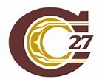
Cariboo-Chilcotin School District
2021-2022 School Plan for Learner Success

School Name: Skyline Alternate School
Ministry of Education Framework: A shared commitment to improve student success, equity and inclusivity of learning outcomes for all students with a particular focus on Indigenous students, children and youth in care and students with disabilities or diverse abilities.
Circle of Courage: (Brendtro, Brokenleg, Van Bockern, 1990) emphasizes the four growth needs of all children: Belonging, Mastery, Independence, and Generosity. This model informs teaching and educational decision-making in the District and is expected to be considered in school planning for learner success.
Intellectual Development
Educational Outcome 1: Students will meet or exceed literacy expectations for each grade level
2020-2021 Results:
- Percentage of students meeting or exceeding literacy expectations:
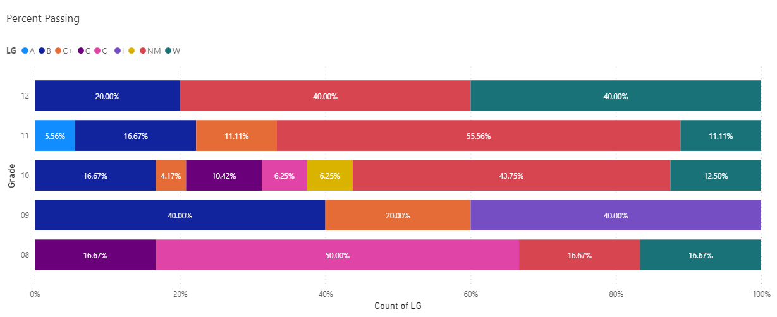

2021-2022 Goals and Focus Areas:
- Have all reading levels assessed and recorded in the student learning plans.
- Have all grade 8 and 9 students assessed with the Dart Assessment tool.
- Become familiar with phone based reading tools to help students transition to adult life with tools for assistance.
Strategies and Structures:
- Actions for Enhancing Student Learning and Experience
  - Take our students out for hikes in nature to build connection and conversation that can relate to school, writing and the arts.
  - Take our students to the farmers market to allow them more interaction with the general public.
  - Support and invite more agency presentations to increase global understanding.
  - Engage in indigenous presentations and workshops to support personal connection to the people and the land.
- Actions for Enhancing Staff Capacity & Learning
  - Discuss professional development opportunities the focus on trauma kids.
  - Discuss professional development opportunities that focus on indigenous understanding and local issues.
  - Develop a strong SOGI representative within the school.
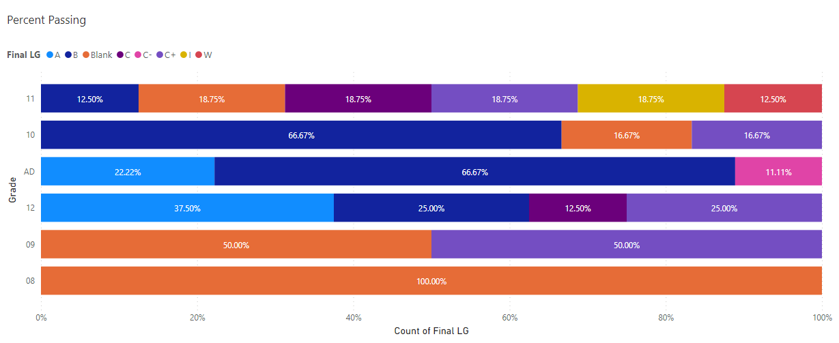

Educational Outcome 2: Students will meet or exceed numeracy expectations for each grade level
Reflection 2022
Grades seem to be steady. We are now going to be addressing our student needs differently targeting the basic skills rather than the course itself.
2020-2021 Results:
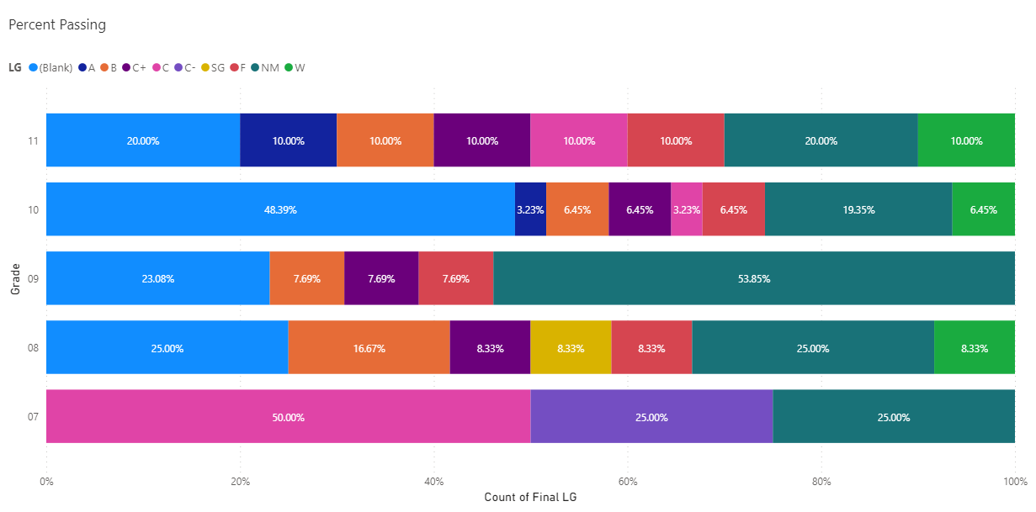

- Percentage of students meeting or exceeding numeracy expectations:
2021-2022 Goals and Focus Areas:
- Increase capacity within our Math classroom.
- Move to a more instructional base program.
- Find alternative ways for student to gain credits for math work (ie work experience and food Safe program).

Strategies and Structures:
- Actions for Enhancing Student Learning and Experience
  - During activity Wednesday try to include a budget that the kids need to develop and shop for.
  - Introduce cooking class as a Wednesday activity.
- Actions for Enhancing Staff Capacity & Learning
- Staff will discuss vision, values and goals to redefine our school.
- Teachers will explore other areas for teaching to enhance student development such as Adulting 101 and the EASEcurriculum.
Reflection 2022
Basic skills continue to be the issue with students at risk. We will now target the skills so students can transition to high schools with more success.
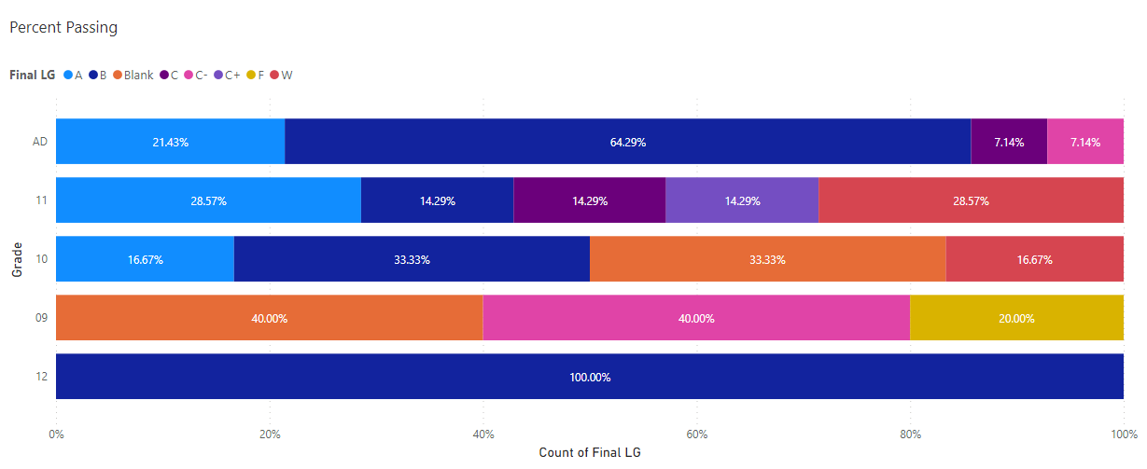

Human and Social Development
Educational Outcome 3: Students will feel welcome, safe and connected to their school
3. 1 Attendance
2020-2021 Results:
- Percentage of students attending 80% or greater end of June 2020:
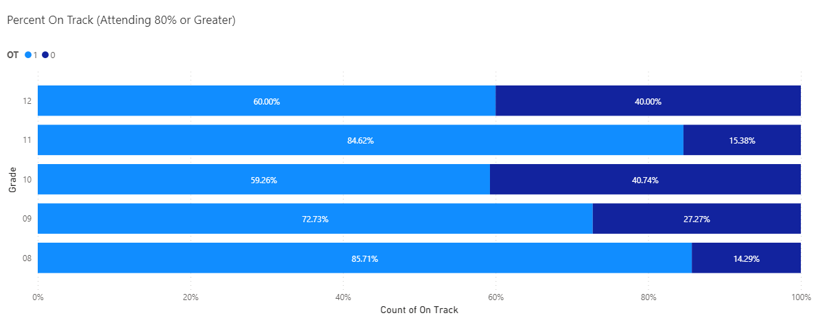

2021-2022 Goals and Focus Areas:
- 100% of students attending 80% or greater end of June 2021
- Emphasize the importance of relationship building.

3.2 Connection to School
2020-2021 Results *Schools may include either or both survey question results in their plan
- Percentage of students in grades 4, 7, 10 who report feeling welcome in their school during 2020-2021
- Percentage of students in grades 4, 7, 10 who report having a sense of belonging in their school during 2020-2021:

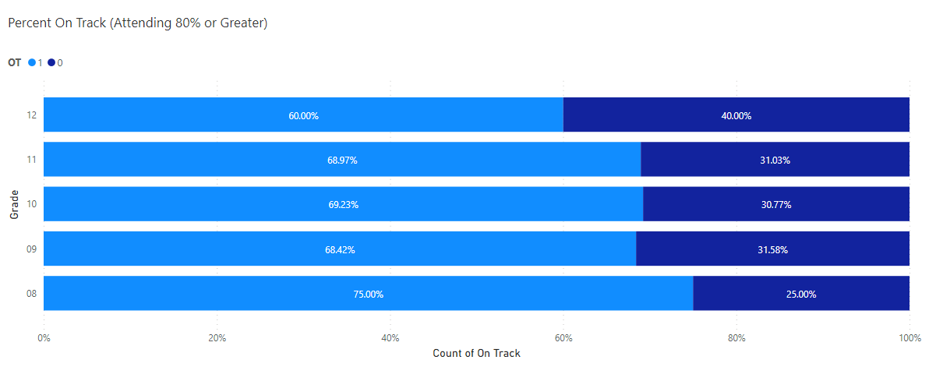

Reflection 2022
Attendance continues to be difficult for some students. We will be making attendance required with our new program with school based team meetings and family intervention being the tool for change.
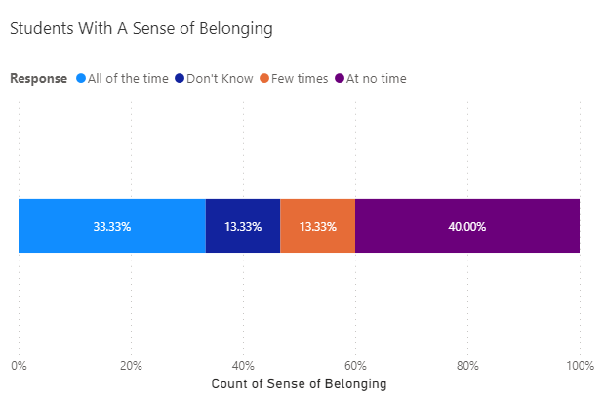

Goals and Focus Areas
- (Please provide 1-3 brief goals based on review of data)
- Roll
Strategies and Structures
- Actions for Enhancing Student Learning and Experience
  - (Please provide 1-3 specific actions that are going to occur in your school this year to change the student experience in relation to your goal areas. Please use a bullet point for each action)
- Actions for Enhancing Staff Capacity & Learning
  - (Please provide 1-3 specific actions that are going to occur in your school this year to support staff development in the above goal area. Please use a bullet point for each action)
3.3 Careers and Core Competencies
Please provide a brief description of how career development and the core competencies will be supported in your school.
Other Focus Area
Please provide a brief description of one or two key focus areas from the district plan for learner success and collective responsibility framework that your school will focus on.

School Team Meeting Schedule:
(Please provide an outline of the schedule that will be followed for reviewing data, monitoring actions, and adjusting plan throughout the school year. Please ensure that all stages of the plan are collaborative and include representation and input from the entire school staff)
Glossary:
(Please provide definitions for all terms, programs, services that would not be widely known and understood by people outside of education)

