* Chilcotin Road Elementary*

*709 Lyne Road*

*Williams Lake, BC V2G 3Z3*

*250-392-5455, Fax: 250-392-6606*

*School District No. 27 (Cariboo-Chilcotin)*

*Home of the Road Runners*

**May Newsletter**

**A Message from your Principal:** Thank you SPRING! I can’t believe this year is almost over. We have so many wonderful things to be grateful for. As we give our final push in these last 2 months, lets work together to keep each of us safe.

Mr. Doug Brown, Principal

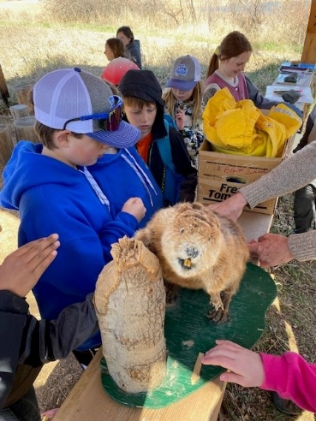

**Big Thank You:**

**Thank you to** our amazing staff for all their hard work and solid educating. We have a very special team here at Chilcotin Road and I am Thankful for each of the members of the team. I also want to thank my PAC for all the wonderful was you support our students at Chilcotin Road.

**Communication & Reminders:**

**Student of the Week at Chilcotin Road:** We have changed things up this year and we are celebrating students a little differently!Everyadult that is connected to our building has a week that they are asked to pick one student that they feel goes above and beyond or, they feel the student is trying hard both with academics and behaviour. This does not replace all of the good celebrations in the classroom, it only helps build and strengthen it. The student receives a certificate for a small pizza from Panago, a $10 gift card to open book, curtesy of our PAC, and a picture with a write up of why the adult picked them. This picture is then displayed on our student of the week board and celebrated at the end of each month. This is the best part of my week, coming in and disrupting a classroom to give the good news of who the adult picked.

**District Plan for Learner Success:**

The District Plan has been approved by the Board and posted to the school district website [Home page ---Our District --- District Plan for Learner Success]. There is a page for how staff, students, parents and caregivers, and community members can engage with and support the work of the plan. Go and check out all of the wonderful posts about Chilcotin Road and all the good learning happening here.

**Safe Arrival Program:** Chilcotin Road will continue to use the student absence reporting system called **“SafeArrival”.** If you need help with the program, please call our office. Please have clear communication with your child’s teacher about absences and other classroom issues. This helps us cut down on calls to the office.

**Code of Conduct:** Families should review the Code of Conduct and the Family Handbook located on our school website. Both documents have been sent out via email as well. Hard copies are available in the office as needed. Our revised Code of Conduct frames all behaviour as communication, with the Circle of Courage at the center. This is a strength based, resilience-focused approach rooted in the principle that to be emotionally healthy, all youth need a sense of belonging, mastery, independence, and generosity. Please review at home with your whole family. Common language supports our collective good work.

**School Food Program:** We are pleased to continue to offer a school food program for students who need it. Breakfast is served every morning now out of our canteen and food is available for those that need it at lunch. There is **no cost** to this program, and **no need to contact** the school office. If you’re interested in helping with our program or have any questions, please contact Doug Brown in the office. If kids are hungry, we will feed them.

**MunchaLunch:** Thank you to our secretary Brandy for her work in coordinating this and to Lisa Ruyter for helping take the pressure off.

**Mark your Calendars / Events:**

**PAC Meeting:** May 8th 5:30pm-6:30pm in the Staffroom – all parents/guardian’s welcome!

**May 1:** Parent meeting for our grade 4-6 mountain bike club/ Principal appreciation Day

**May 2:** Anything but pants Day

**May 12:** Mud run 11-1pm Mountview

**May 13:** Staff meeting 2:45 Library

**May 15:** Wear Red and Shades Day

**May 19:** Victoria Day long weekend

**May 21:** Class photo/school photo day 9:00 a.m.

**CANCELLED DAY May 23:** Sports Day/Scavenger Hunt THIS DATED CANCELLED AND REBOOKED AS BELOW

MAY 22 – SCAVENGER HUNT

MAY 29 SPORTS DAY – INTERMEDIATTE TRACK AND FIELD QUALIFIER

**May 26:** Bike Rodeo

**You can also find our Chilcotin Road PAC on Facebook: “**Chilcotin Road PAC” - This is a good resource to check for new or updated school celebrations of school community and culture. We ask that only parents of Chilcotin Road Elementary join this page.