### 150 Mile Elementary School

**Code of Conduct**

**Mission**

Ensuring all students have meaningful learning experiences, empowering them to succeed in an ever-changing world.

**Vision**

We envision an encouraging and understanding learning environment where everyone demonstrates a sense of belonging, mastery, independence, and generosity.

**Values**

The values that the school will hold itself to are embodied in the ideals of Safety, Tolerance, Accountability and Respect.

**SCHOOL CODE OF CONDUCT 2023-2024**

1. **Purpose**

At 150 Mile Elementary we hold a common belief in a set of rights and responsibilities which supports a safe, caring and orderly learning environment where students feel a sense of belonging, pride in their school, and where people in the school community are respectful, fair, and where they feel safe to work and learn.

Accompanying these rights and responsibilities is a set of rules which provides a framework for school discipline, while at both school and school related activities. We believe that in order to have and maintain a positive school environment a cooperative effort between parents, staff, students and the community is imperative.

##### Acceptable behaviors would be generalized as any behaviors that promote each student’s rights and responsibilities; conversely unacceptable behaviors would be any behaviors that do not promote each students rights and responsibilities

##### Development and Regular Review

The 150 Mile Elementary Student Code of Conduct will be reviewed annually by students, staff and parents (through PAC) in September of each school year. However, should a situation arise where the Code of Conduct needs to be reviewed after September of each school year, time will be afforded to address the issue. The Student Code of Conduct will be continually monitored to ensure it is reflecting current and emerging situations throughout the school year.

##### Communicating Expectations

The Code of Conduct is to be communicated to students via classroom discussion and through the 150 Mile School Website. Copies will be retained in the office for parents, temporary staff, school community members and visitors as required.

##### Behavioral expectations are explicitly taught and promoted during school assemblies. Teachers incorporate lessons into their classrooms. Behaviors are modeled and students actively participate in role plays or demonstrations of positive behavior expectations.

##### Expectations of Acceptable Conduct

**Students Rights and Responsibilities**

**All students have rights and responsibilities. These rights and responsibilities include**

**The right to:**

* to be treated fairly and with respect and dignity
* be free from discrimination in any form
* to be safe
* to a quality educational program

**The responsibility to:**

* come to school prepared, on time and ready to learn
* show respect for themselves, for others and for those in authority
* refrain from bringing anything to school that may compromise the safety of others
* follow the established rules and take ownership for their own actions

|  |  |  |  |  |  |  |  |  |  |  |  |  |  |  |  |  |  |  |  |  |  |  |  |  |  |  |  |  |  |  |  |  |  |  |  |  |  |  |  |  |  |  |  |  |  |  |  |  |
| --- | --- | --- | --- | --- | --- | --- | --- | --- | --- | --- | --- | --- | --- | --- | --- | --- | --- | --- | --- | --- | --- | --- | --- | --- | --- | --- | --- | --- | --- | --- | --- | --- | --- | --- | --- | --- | --- | --- | --- | --- | --- | --- | --- | --- | --- | --- | --- | --- |
| Acceptable behavior needed to create an atmosphere of trust and security in which students may grow in confidence because of their actions and achievements include:   |  |  |  |  |  |  |  |  | | --- | --- | --- | --- | --- | --- | --- | --- | | **Behaviour Expectations** | **Respect Ourselves** | **Respect Others** | **Respect Property** |  |  |  |  | | Classroom | -Come prepared  -Use appropriate language  -Try your best | -Put your hand up for help  -Share  -Keep your hands and feet to yourself | -Keep your personal space clean  -Put garbage in the trash can  -Wash your hands often |  |  |  |  | | **Playground** | -Play with others  -Use nice words  -Play safe | -Take turns  -Share equipment  -Respect others space | -Use equipment properly  -Put garbage in trash cans |  |  |  |  | | **Hallways** | -Walk  -Use quiet Voices | -Walk on the right side  -Hold the doors for others | -Leave outdoor shoes on rack  -Keep feet off of furniture |  |  |  |  | | **Assemblies** | -Sit quietly  -Listen to instructions | -Pay attention  -Clap for others  -Stand for Oh Canada  -Sing with your best voice | -Sit in one spot  -Keep chairs flat on the floor |  |  |  |  | | Fieldtrips | -Listen to and follow instructions  -Always travel in a group | -Be aware of others  -Tell the teacher if you see a problem  -Be helpful to your classmates and leaders | -Respect the environment  -Respect other property |  |  |  |  | |
| The above behaviours are expected of students while they are in attendance at school, while travelling to and from school, and while attending any school function at any location. |
| School District #27 considers the possession or any use of any weapon by anyone on school premises to be a serious threat to the school environment and to the safety of both students and staff. A weapon is defined as:  *Anything used, or intended for use, to threaten or intimidate any person and, without restricting the generality of the foregoing, includes any replica weapon or firearm.* |
| The Code of Conduct shall address all the prohibited grounds of discrimination set out in the BC Human Rights Code, as they relate to the school environment(s.7)  *People are protected by virtue of their, real or perceived, race, colour, ancestry, place of origin, political belief, religion, marital status, family status, physical or mental disability, age, sexual orientation or gender identification and therefore should not be subjected to discriminatory actions, including publication or discrimination of service.* |
| The Board of Education of School District #27 will take all reasonable steps to prevent retaliation by a person against a student who has made a complaint of a breach of the Code of Conduct. |
| It is expected that while involved in school related functions of any nature that students, parents, coaches and involved members of the greater community follow the school code of conduct as they are in essence acting as ambassadors of the school and these expectations are made known.   1. **Consequences for Unacceptable Conduct** 2. In the event that a breach of conduct by a student occurs, certain behaviors have been highlighted as well as a disciplinary action plan in an effort to provide students, parents and staff with a guideline for disciplinary proceedings and protocol. 3. Where consequences for unacceptable behavior are concerned, whenever possible and wherever appropriate, consequences shall be restorative rather than merely punitive in nature (ex. actions of a discriminatory nature). The design of the level 1, 2 and 3 behaviors is meant to address the very issue of restorative rather than punitive actions (see below). 4. In no way is this list meant to be wholly comprehensive as situational variables must be considered in all cases in an effort to best meet the needs of all parties involved in disciplinary incidents. Consideration will be given to a student’s age, maturity, and special needs as well as the student’s previous school record. 5. Special considerations may apply to students with special needs where appropriate. (These are students who may not be able to fully comply with a code of conduct because of their special needs). As students grow older and move through successive grades at 150 Mile Elementary it is expected that their maturity will increase and accordingly be held to a higher standard of personal conduct. 6. The use of suspension will only be considered when violation of the Code is serious or other consequences have been inadequate or ineffective. 7. On occasion school officials may have a responsibility to advise other parties of serious breaches of the code of conduct. (e.g., parents, school district officials, police and/or other agencies). 8. Teachers are responsible for developing their own Classroom Management Plan. Within this plan, there will be classroom expectations, classroom recognition, and classroom consequences that will be explained to all students at the beginning of the year and that are consistent with and complement the School Code of Conduct 9. The school will take all reasonable steps to prevent retaliation against a student who has made a complaint of a breach of the code of conduct. |

**Unacceptable/Inappropriate Conduct**

**Level 1 Behaviors**

The attending adult handles the following behaviors:

* + Disruptions/Disobedience
  + Lack of effort
  + Lack of respect
  + Inappropriate language/behavior
  + Homework issues
  + Inappropriate assembly/audience behavior
  + Breach of school rules/policies
  + Excessive tardiness or absenteeism

## Level 2 Behaviors

The following behaviors are dealt with by the attending adult then reinforced by administration:

* + Lack of respect (Major)
  + Harassment
  + Defiance/Willful Disobedience
  + Inappropriate internet use
  + Disrespect of teachers’ personal space and belongings
  + Inappropriate behaviours on school trips
  + Cheating or plagiarism

**Level 3 Behaviors**

The following behaviors require immediate office referral:

* + Bullying
  + Repeated/Major harassment
  + Direct disobedience
  + Intimidation
  + Theft and vandalism
  + Inappropriate sexual activity
  + Fighting/Assault
  + Endangering safety
  + Drug and alcohol infractions
  + Possession/use of weapon
  + Inappropriate smoking/tobacco use

**School – Wide Consequences – A Guideline**

**LEVEL 1 BEHAVIOURS**

**Step 1** – Remind student of behaviour expectations

**Step 2** – Restitution by the student

**Step 3** – Home Contact by the teacher

              Completion of **Student Plan of Action** by the student

**Step 4** – Move directly to “Level 2 – Step 2”

**LEVEL 2 BEHAVIOURS**

**Step 1** – Restitution by the student

               Completion of **Student Plan of Action** by the student

**Step 2** – Referral to Principal

               Home contact by Principal

**1 to 3 day in-school parent supervised suspension/home suspension**

**Step** **3** – Referral to Principal by teacher

               Home Contact by Principal

               1 to 5 days out of school suspension

               Parent conference with Principal before student returns

               Student Contract and behaviour plan

**Step 4** – Move directly to “Level 3 – Step 2”

**LEVEL 3 BEHAVIORS**

**Step 1** – Referral to Principal

               1 to 3 day in school parent supervised suspension/home suspension

               Parent conference with principal

**Step 2** – 1 to 5 days out of school suspension

**Step 3** – Indefinite Suspension – referral to District Discipline Committee

SCHOOL DISTRICT #27

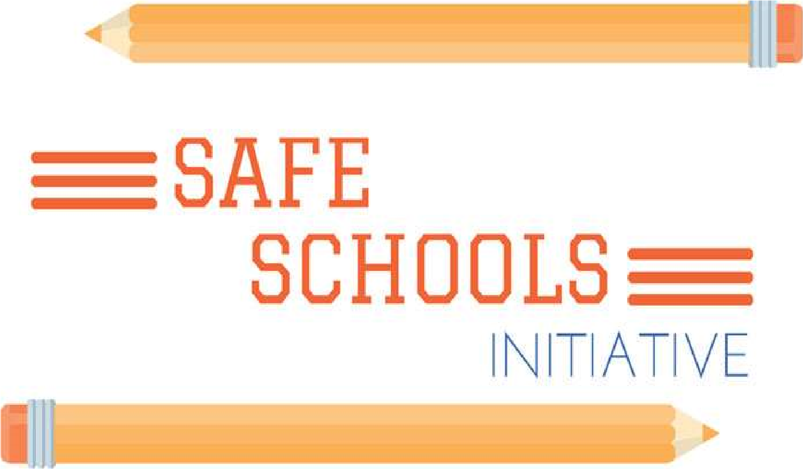

What behaviours initiate a student threat assessment?

A student threat assessment will be initiated when behaviours include, but are not limited to, serious violence or violence with intent to harm or kill, verbal/written threats to harm/kill others, internet website threats to harm/kill others, possession of weapons (including replicas), bomb threats and fire setting.

Duty to report

To keep school communities safe and caring, staff, parents, students and community members must report all threat-related behaviours.

What is a threat?

A threat is an expression of intent to do harm or act out violently against someone or something. Threats may be verbal, written, drawn, posted on the internet or made by gesture. Threats must be taken seriously, investigated and responded to.

What is a Threat Assessment Team?

Each school has a Threat Assessment Team which is multi-disciplinary. The team may include principal, vice-principal, school counsellor, learning support teacher and police.

What is the purpose of a student threat assessment?

The purposes of a student threat assessment are:

* To ensure the safety of students, staff, parents and others.
* To ensure a full understanding of the context of the threat.
* To understand factors contributing to the threat makers’ behavior.
* To be proactive in developing an intervention plan that addresses the emotional and physical safety of the threat maker.
* To promote the emotional and physical safety of all.

What happens in a student threat assessment?

All threat making behavior by a student shall be reported to the principal who will activate the protocol for the initial response. Once the team has been activated, interviews may be held with the student(s), the threat maker, parents and staff to determine the level of risk and develop an appropriate response to the incident. Intervention plans will be developed and shared with parents, staff and students as required.

Can I refuse to participate in a threat assessment process?

It is important for all parties to engage in the process. However, if for some reason there is a reluctance to participate in the process by the threat maker or parent/guardian, the threat assessment process will continue in order to promote a safe and caring learning environment for all.