***Cariboo-Chilcotin School District No. 27***

**2023-2024 School Plan for Learner Success**



**School Plan – 150 Mile Elementary 2023-24**

**Ministry of Education Framework:** A shared commitment to **improve** student success, equity and inclusivity of learning **outcomes for all students** with a particular focus on Indigenous students, children and youth in care, and students with disabilities and diverse abilities.

******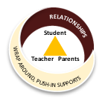**District Plan for Learner Success:** School Plans for Learner Success are aligned with the goals and focus areas for improvement of the District plan. Unique priorities, needs, and strengths of the school community are reflected in the school-specific plans.

**SD 27 Framework for Collective Responsibility:** support for students is the responsibility of everyone in the District. It is guided by a framework which includes common information, effective team structures and processes, strategic responses, and collaborative relationships.

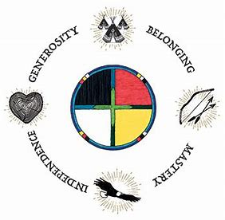**Circle of Courage**: (Brendtro, Brokenleg, Van Bockern, 1990) emphasizes the four growth needs of all children: Belonging, Mastery, Independence, and Generosity. This model informs teaching and educational decision-making in the District and is expected to be considered in school planning for learner success.

**Intellectual Development**

**Educational Outcome 1:** **Students will meet or exceed literacy expectations for each grade level**

2022-2023 Results:

* 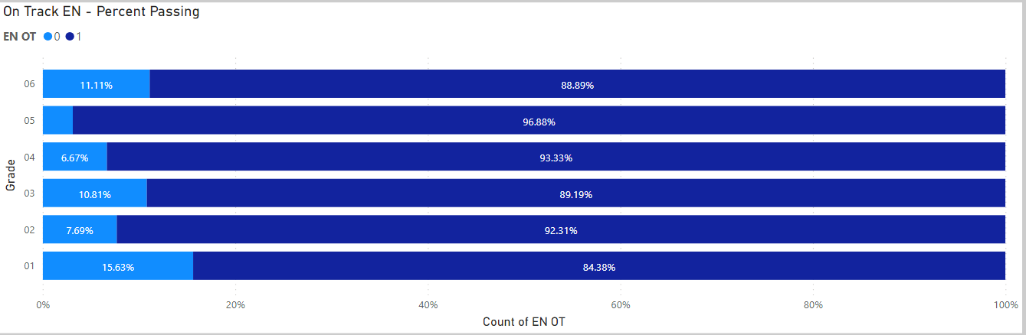Percentage of students meeting or exceeding literacy expectations: 2022-2023

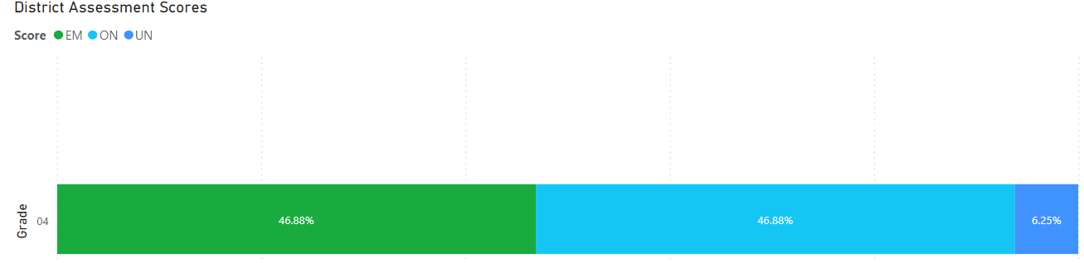

Goals and Focus Areas:

* Improve the number of students in grades K-6 reading and writing at proficient level.
* Increase common classroom practices inform by best practices and current research
* Increase phonological awareness and early literacy skill development

Strategies and Structures:

* Actions for Enhancing Student Learning and Experience
  + Explicit teaching of reading/writing strategies exposed by DART/EPRA/SWW results
  + Improve percentage of Indigenous students grades K-6 proficient or extending.
  + Focus on phonological awareness in early primary grades
* Actions for Enhancing Staff Capacity & Learning
  + Changing Results for Young Readers
  + Staff collaboratively assess results of DART/EPRA/SWW
  + Use of after school meetings for collaboration time (monthly). These are volunteer based, informal

**Educational Outcome 2:** **Students will meet or exceed numeracy expectations for each grade level**

2022-2023 Results:

* 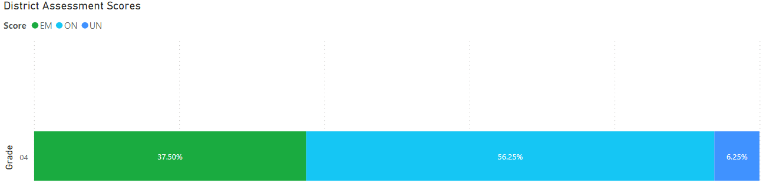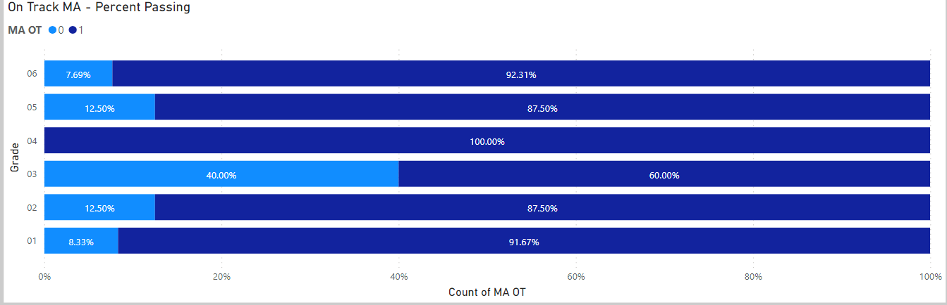Percentage of students meeting or exceeding numeracy expectations: 2022-2023

2022-2023 Goals and Focus Areas:

* Teaching foundational math skills in all grades (K-6).
* Staff collaboration to develop strong scope and sequence to ensure continuity of skill development

Strategies and Structures:

Actions for Enhancing Student Learning and Experience

* Common assessments
* Improve and update math resources
* Incorporate more vertical learning in all classrooms

Actions for Enhancing Staff Capacity & Learning

* Increase staff engagement in the SD #27 learning series

**Human and Social Development**

**Educational Outcome 3:** **Students will feel welcome, safe and connected to their school**

***3. 1 Attendance***

2022-2023 Results:

* 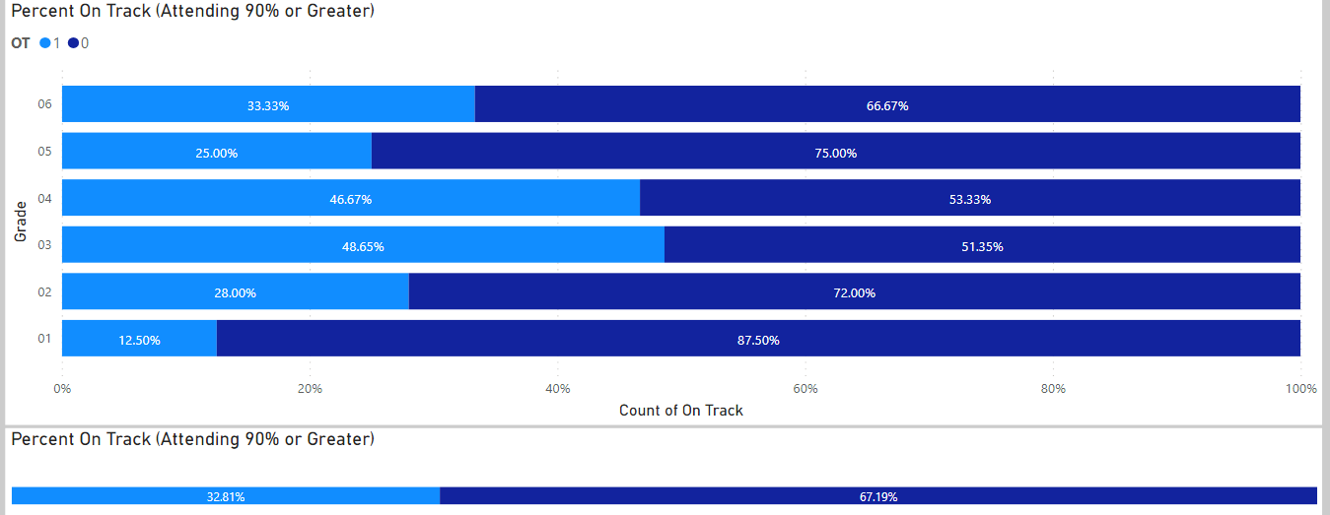Percentage of students attending 80% or greater end of June 2020:
  1. Goals and Focus Areas:
* 100% of students attending 80% or greater end of June 2021
* Increase sense of belonging for all students, in particular Indigenous learners

Strategies and Structures

Actions for Enhancing Student Learning and Experience

* + Use 7 Sacred Teachings ‘caught you’ tickets,
  + Monthly recognition assemblies – highlighting student efforts in Arts, academics, Citizenship and Athletics
  + increase Indigenous content in all areas of the curriculum
  + Increase Indigenous themed content in the school
* Actions for Enhancing Staff Capacity & Learning
  + Reviewing monthly the First Nations Principles of Learning
  + Monthly discussions highlighting support for Indigenous students - specifically on-reserve students

***3.2 Connection to School***

2022-2023 Results : none available

* Percentage of students in grades 4, 7, 10 who report feeling welcome in their school during 2022-2023
* Percentage of students in grades 4, 7, 10 who report having a sense of belonging in their school during 2022-2023

Goals and Focus Areas

* As this area is linked to attendance please refer to attendance goals and focus areas

Strategies and Structures

Actions for Enhancing Student Learning and Experience

* See attendance strategies and structures

Actions for Enhancing Staff Capacity & Learning

* See actions for enhancing staff capacity and learning

**Career Development**

**Educational Outcome 4:Students will have the core competencies to achieve their career and life goals**

* Will encourage all staff to complete EASE training and actively engage their students in the curriculum.
* We will also make a concerted effort to ensure students are completing self-reflections on core competencies linked to their school/classroom work

**Other Focus Area(s) Aligned with District Plan for Learner Success**

**COLLECTIVE RESPONSIBILITY**

**SYSTEMS THINKING**

**LEADERSHIP CAPACITY**

**INSTRUCTIONAL CAPACITY**

**INCLUSIVE LEARNING COMMUNITIES**

**INDIGENOUS LEARNING & CULTURE**

**PLACE-BASED**

**LEARNING**

**Place-based Learning** will continue to be a focus. This will be our first year as a HCTF WILD School, implementing this program will hopefully increase teacher capacity for teaching outside.

1. Invest in equipment for outdoor activities and learning
2. Ensuring all students have access to proper clothing for outdoor activities
3. Support all staff in learning opportunities to build capacity for outdoor learning

**Indigenous Learning and Culture**: Using the Indigenous Calendar and Handbook developed by the district SLT, we will attempt to action quality monthly events for our indigenous and non-indigenous students that builds knowledge and understading:

1. Staff continuing their learning about Truth and Reconciliation
2. Staff participation in the District Day with Jo Chrona
3. Intentional use of the First Peoples Principles of Learning
4. Increased First Nations language and culture at school
5. Ensure the all library and resource collections have authentic resources

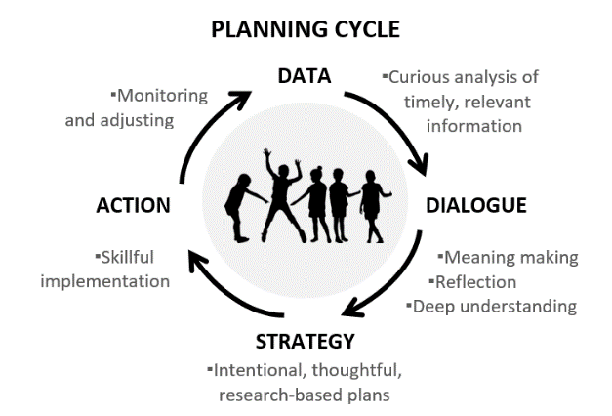**School Team Planning Cycle**

Each month the school teaching team will meet review school programs and plans that reflect goals, and strategies outlined in the school plan. The school plan will have a regular place for discussion at monthly staff meetings to edit make adjustments as necessary with staff input.

Fall: Introduce and update the school plan.  Reviewing results from the previous school year and fall assessments as a staff.

Winter: Review Term 1 report card and FSA data as a staff. Review focus areas of school plan and modify target areas as required.

Spring: Review Term 2 report data as a staff.  Review focus areas of the school plan and adjust target areas as needed. Complete district assessments including EPRA/DART and School Wide Write.  Review student learning survey results if available. Review all available data for school plan development for the 2024-25 school year.

**Glossary**

FIEPRA/EPRA / DART –Performance-based reading assessments, designed in British Columbia, by cohorts of British Columbia educators, in response to teachers’ questions about how best to use assessment information to guide their reading instruction

FSA – Foundation Skills Assessment: Provincial assessment at the grade 4 and 7 level for Reading, Writing, and Numeracy.

SBT – School Based Team: A team led by the principal that assists classroom teachers to develop and implement instructional and/or management strategies and to coordinate support resources for students.

SSW - School Wide Write – A SD 27 school-wide writing assessment completed by grades 1-9 every fall and spring.